***Car Mechanic AR App***

Goldsmiths University of London

BSc Computer Science

Argjend Statovci

033460879

Supervisor: Nick Hine

**Abstract**

Car Mechanic AR Application is designed and created to help students learn about different car component and how to fix common problems that can occur. The application provides an Augmented Reality experience so that the students will learn in a better and more exciting way.

Car Mechanic AR Application works by allowing the user to use their smartphone camera to scan a car component and the application will try to identify it. The application will display an AR label over the car component which contains information about it and how to fix common problems that can occur.

**Acknowledgments**

I would like to thank my supervisor Nick Hine for providing me support through this project process. He offered me so much professional advice and ideas that helped me produce this project. I couldn’t have asked for a better supervisor.

I would like to thank the Technicians of the Goldsmiths University of London as they kindly allowed me to borrow equipment that was essential for the creation of this project. Finally, I would like to thank my caring, loving family as they’ve helped me through the stressed times where I felt like giving up on this degree.

Contents

**1 Introduction**7

1.1 Aims and Motivation7

1.2 The Project and Required Tools8

**2 Background Research**8

2.1 Motivation and Justification9

2.1.1 Markerless Augmented Reality9

2.1.2 Superimposition-based Augmented Reality10

2.1.3 Projection-based Augmented Reality10

2.1.4 Marker-based Augmented Reality11

2.2 Interview with Client 12

2.3 Existing Applications13

2.3.1 ‘How a car works’13

2.3.2 Hyundai AR App14

2.3.3 BMW Augmented Reality Car Repair App15

2.3.4 I-Mechanic AR Application17

2.4 Technology Research19

2.4.1 ARKit 219

2.4.1.1 ARKit 2 New Features20

2.4.1.2 Shared AR Experiences20

2.4.1.3 USDZ File Format20

2.4.1.4 Environmental Texturing20

2.4.1.5 3D Object Detection21

2.4.2 Swift21

2.4.3 3D Scanning Application22

**3 System Design**23

3.1 System Requirements23

3.1.1 Car Mechanic AR Application Requirements24

3.2 System Process Diagram24

3.3 System Storyboard25

3.4 Overhead Label Design27

**4 Implementation**28

4.1 Scanning the Car Components29

4.1.1 Scanning Process30

4.2 Creating the Car Component Labels33

4.3 Implementing the labels on the Car Components34

**5 Testing and Evaluation**38

5.1 Black Box Testing39

5.2 User Testing43

**6 Conclusion**54

6.1 Application Successes54

6.2 Application Failures54

6.3 Future Developments55

6.3.1 Quiz55

6.3.2 Login55

6.3.3 Responsive Overhead Labels55

**Bibliography**56

**Appendices**

**Appendix A: Survey Questions for User Testing**

**Appendix B: *Car Mechanic Application Screenshots***

**Appendix C: Car Component Labels**

**Appendix D: *Car Mechanic Application Code***

**Appendix E: *Project Plan***

**1 Introduction**

**1.1 Aims and motivation**

The aim of this project is to go out and make something new that could benefit the desired target audience which are students that are undergoing a motor vehicle course. Most motor vehicle courses teach students about car maintenance, car repairs, car bodywork, and health and safety regulations. These aspects are normally taught by lecturers and through the use of textbooks which can be a boring method for some candidates. However, there are some colleges that have workshops which allow their students to put their knowledge into practice. knowing this it came into attention that there needs to be a system that could help students learn and practice at the same time.

Since AR technology is becoming more advanced, it would make sense to create an augmented reality application such as *Car Mechanic AR Application* which will help users learn about different parts of the vehicle and teach them how to fix common problems. The *Car Mechanic AR Application* can achieve this by identifying each car component and displaying virtual labels over them which contain information about the component, common problems that can occur and how to repair or prevent those problems. If successful, *Car Mechanic AR Application* would be very beneficial for the students as they could use it to learn about different car components but in a more adventurous way. They will be able to use virtual elements to interact with the real world which will give them a more immersive experience depending on how well the AR application is implemented.

Although *Car Mechanic AR Application* is specifically targeted for students studying car mechanics, it can also be used by people who own cars. They can use it to learn about car components and if they experience any issues with their car, they could use the application to help them fix it. This way they’ll save money from going to their local mechanic to repair something that they could simply do themselves.

* 1. **The Project and required tools**

The project consists of three main parts which allow the application to work properly. The first part is acquiring an AR development platform so that the application can be implemented to contain AR features. This tool is known as Apples ARkit2 and contains features such as the ability to incorporate real-world objects into AR experiences which gives the user a more immersive experience. Knowing that the ARkit2 has these abilities it would make more sense to use this for the implementation of the *Car Mechanic AR Application*.

The second part required to create the *Car Mechanic AR Application* is to use Apple’s scanning and detecting 3d objects kit. This is a sample code developed by Apple which allows developers to scan real-world objects and work with them. So, this sample code would be used to scan the car components an import them into the project assets folder. With the correct implementation, the AR car mechanic application will be able to identify the scanned component whenever its camera is positioned over the real-life car component.

The third part is to implement overhead labels for the scanned models so that whenever the users try to scan a car component, the appropriate label will appear over the object. This label will contain information about the car component such as what it is, what it does, common issues that can occur and how to fix those issues. The labels can be created using the spritekit scene in XCode. The labels are formed by inserting planes, information labels, and images. However, for them to appear on the scanned car components, they require some implementation specifically using a programming language such as swift.

**2 Background Research**

This chapter focuses on the research aspects of the project which is very much the first thing that should be undertaken when creating a piece of software for a client. A large amount of time was spent on this area since it is important to find out what the problem is and how other people have tried to tackle it. There are some existing applications that have a similar purpose to what this project is trying to achieve but by analyzing what’s already out there, you can find out their weaknesses and look for ways this project could make those features better.

**2.1 Motivation and justification**

Technology has been evolving ever since it was introduced into the world. People are inventing technologies to benefit different types of users and some of these technologies have changed the way people live their lives. A typical example would be a smartphone which is one of the most popular technologies to exist and is almost used by everyone in the world. When the smartphone was first introduced, it was mainly used for cellular communication but over the years it has been rapidly evolving and its uses are becoming more diverse. Mobile technology has presently transformed into a digital world and has made life and business much easier; marketers now have the ability to sell their products with ease through mobiles technology (Macwan, 2017). In other words, smartphones are essential in our day to day lives. So, most developers will look into this and will perhaps create software or applications that can specifically be used on mobile technology since it has a vast number of users.

Since mobile technology seems to be very popular, it makes perfect sense to create an application that is designed to be used on a smartphone platform. However, creating an application can be uncreative and may not be beneficial on the target audience. So, to enhance the users experience the application needed to be designed and created in augmented reality. This piece of technology is “An enhanced version of reality where live direct or indirect views of physical real-world environments are augmented with superimposed computer-generated images over a user’s view of the real-world, thus enhancing one’s current perception of reality” (Admin, 2018). There are four types of augmented reality such as marker-based reality, markerless augmented reality, superimposition-based AR and projection-based AR. These types of augmented reality, function differently and in a way offer the users different experiences.

**2.1.1 Markerless Augmented Reality**

This type of augmented reality operates differently compared to marker-based AR. Markerless augmented reality is triggered by geolocation, user input and or even spatial recognition. It uses advanced technology such as SLAM (simultaneous location and mapping) which enables users to place their AR experiences like 3D models wherever they want but it's only possible if it’s done on a flat surface (Davis, 2017). Markerless AR applications will often make use of the device’s built-in technology such as gyroscope, accelerometer and a GPS so that it can provide data based on the user’s location. With this data, the AR application can decide what is displayed to the user or what they’ll expect to see in certain locations they visit (Team, 2019).

Developers have taken advantage of markerless augmented reality and have created AR apps that make use of the devices GPS, geolocation and gyroscope. Typical markerless AR applications would furniture placement applications which allow users to place 3D models of furniture into their home. This will allow them to see the furniture’s measurements and get a better idea of how it would look like if they were to purchase it the real-life furniture.

**2.1.2 Superimposition-based Augmented Reality**

Superimposition-based augmented reality is a fascinating piece of technology the way it works. This type of AR can allow users to replace the real-life object with an augmented reality version of that object. This augmented reality object could be replacing some parts of the real-life object or it could be fully replacing the whole object. However, these actions are only achievable because superimposition-based AR uses object recognition so that the exact object is shown rather than a random one. A typical example of where superimposition-based augmented reality is used would be the IKEA app which allows users to choose virtual furniture items from IKEA’s digital catalog and place them in their homes. This is one of the greatest inventions to exist because users are able to transform the look of their home before actually purchasing the furniture (Agarwal, 2019).

**2.1.3 Projection-based Augmented Reality**

Projection-based augmented reality is an interesting type of technology where it purely focuses on projection techniques using devices that have the capabilities of projecting light on objects or flat surfaces. There are many different approaches this type of AR uses, for instance, one of them is projecting light onto a real-life flat surface and making it interactive with human touch. The interaction is achieved by using sensors which are programmed to detect human touch. An example of a projection-based augmented reality application that uses project and sensors would be an application which projects light of a calculator onto the user’s palm. The 12 partitions on the user’s hand will be represented as 12 buttons which the user can interact with them by simply tapping the button and it will output the numbers (Singh, 2018).

Another Projection-based augmented reality approach is using laser plasma technology to project 3D holograms in mid-air. This is beneficial in circumstances where you have an image that needs to be projected into a 3D hologram so that you can study the structure and detail of the image in more depth (Singh, 2018).

**2.1.4 Marker-based Augmented Reality**

The concept behind marker-based augmented reality is that a device's camera such as a smartphone camera captures the visuals of the environment in which then the application within the device recognizes certain parts of the environment and displays an output. The application could output from anything like a 3D model, animation models, videos, images, audio files and many more (Prabhu, 2017). The only reason marker-based AR is possible is that it uses a camera to focus on the environment's objects and look out for any visual markers. These visual markers are often represented as real-life objects, images and or even simple patterns such as a QR code (Prabhu, 2017). Whenever a marker has been recognized, the position and orientation are calculated by the AR application so that it can be decided how to display the output. As soon as this is done, the AR application will place the output over the position of the marker. So, if the output is deemed to be a 3D model of the real-life object, the model would be placed over the object which the user can use the device to look around the model’s detail at different angles. It is even possible to interact with the 3d model such as rotating it resizing it or even reposition it which can make the experience more immersive, only if the marker-based AR application is implemented properly.

**2.2 Interview with Client**

A meeting with the head of a motor vehicle course from a local college was required in order to make this project successful. It is important to work with the client to find out what their exact requirements are so that there is enough information to be able to come up with a design for the *Car Mechanic AR App*.

During the meeting, some important questioned were asked to the client such as what he currently teaches the students and how are they assessed. He mentioned that most parts of their course involve getting students to work with real physical cars. They teach the students how to carry out routine Vehicle Maintenance, wheel alignment, removing and refitting car parts and health and safety. His students are assessed on how well they can perform the tasks taught to them and they are also assessed by completing online tests.

The *Car Mechanic AR Application* idea and concept was explained to Mr. Hayman in which he replied saying that this would be beneficial for students to learn more about how to perform certain mechanic tasks and it would be a great revision tool for the online tests. Mr. Hayman was asked which platform he would prefer the *Car Mechanic AR Application* to be created on. He suggested that the *Car Mechanic AR Application* should be designed to be used on iOS (iPhone OS) because the college allows students to borrow iPad’s which means that they’ll be able to use the application on their devices.

In order for *Car Mechanic AR Application* to become successful, it needs to work on the cars the colleges allow their students to work on. So, an agreement had to be made with Mr. Hayman about how the *Car Mechanic AR Application* would be created to work with their cars because the application will only be able to identify the car components if it has scanned models of the components stored into is assets. So, he granted permission to work with his cars under his supervision.

Furthermore, Mr. Hayman has allowed for the *Car Mechanic AR Application* to be tested by his students so that it will give us a better understanding as to if the target audience enjoyed their experience using *Car Mechanic AR Application.* Also, with the feedback received from the students, we can come to a conclusion and figure out whether the *Car Mechanic AR Application* was a success or not.

**2.3 Existing Applications**

Based on the feedback received from Mark Hayman, further excessive research has been done to find out about any AR apps that work similarly to what this project application is set out to do. There were a few AR apps that currently exist, where some of them looked great whilst others weren’t as amazing as they could’ve been. Some of the AR applications make use of different types of augmented reality approaches which were mentioned earlier but some of them are required to use special technology in order for the AR application to work. Below are some examples of AR applications that are similar to *Car Mechanic AR* in terms of the concept.

**2.3.1 ‘How a car works’**

‘How a car works’ is one augmented reality iOS application which teaches users how to cars work. The user can learn everything about cars, read articles with illustrations and use the AR camera to explore different models. One great feature about this app is the fact that you can disassemble each model so you can see each different elements that makes up that model. The animations are good quality and play at an appropriate speed so you can catch everything that happens at each step. However, this app only allows users to access one model which is the engine. You need to purchase the other models and features within the app which is a big downfall (How a car works, 2015).

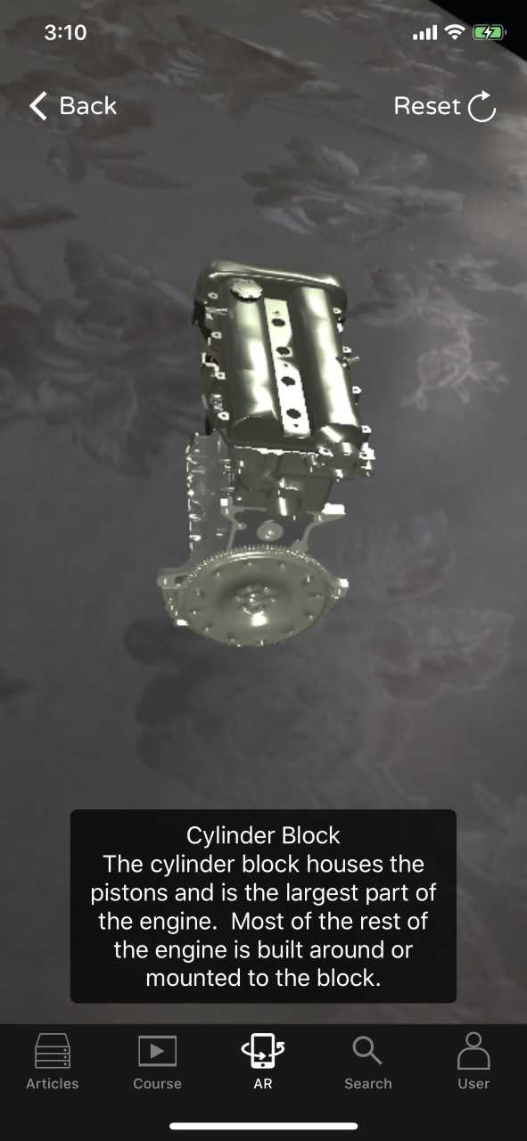

This figure shows the ‘How a car works’ AR application being used on an iOS device. The app looks neat and simple. The buttons on the panel are clear and easy to understand which is important when it comes to providing a good users experience. The user shouldn’t have to struggle to find their way through the app. You can tell that the developers of this AR application have thought wisely about designing the application in a professional manner so that it becomes a success on the market. However, the one drawback about this application is the 3D augmented model looks cartoonish which some parts may not look similar to how they look in real life. This could have an effect on what the user actually learns because what is demonstrated by the 3D model may be difficult to demonstrate with real-life version.

**2.3.2 Hyundai AR App**

Hyundai’s idiot-proof car maintenance AR app is another example of a car fixing AR app that currently exists. Hyundai is a company that makes cars, decided to create an AR app for their customers to help them learn about their cars and learn how to fix basic problems that could occur within the car. This app noticeably has some great features that are thought to be beneficial to have in augmented reality. For instance, the app can scan each component it sees and identifies what that component is. For every element of the car it recognizes, it will display labels on top of them, so the user knows what each element is and what it does (Golson, 2016). However, this app is more like an AR instruction manual and mainly focuses on how to operate the car dashboard.

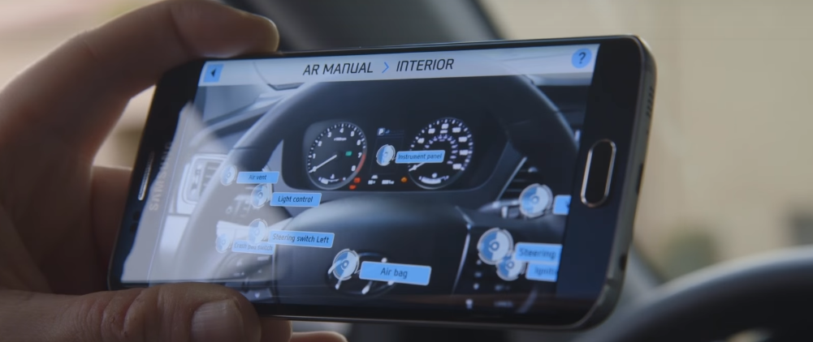

By looking at the image above you can see how the Hyundai AR app looks like when it is being used by an individual. You can see that the individual has positioned the phone over the car’s wheel/dashboard and the app manages to identify the car parts and display the appropriate labels on top of the parts. The labels have a pointer indicating which component has been identified and within the label the name of the car component displayed. Hyundai has done a great job with this app as it gives their customers a more interactive way of learning about their cars. It’s much better and more convenient using this app to learn about the car parts rather than reading the manual book. But as we all know that some people are old fashioned and prefer to use the traditional manual handbook most car manufacturers supply their customers with, simply because they may not have the technical knowledge to use advanced software like augmented reality. Also, applications are likely to experience bugs which aren’t ideal for users to use because some parts of the app will stop working or will not display information properly.

**2.3.3 BMW Augmented Reality Car Repair App**

Since 2009 BMW has been working on a project to create an AR application that teaches you how to perform repairs on their car models. However, this AR application requires the use of AR smart glasses. This AR application is still being developed by the BMW team, but they have released footage showing how the application works. “The idea is that by wearing these glasses, you will be able to glance over a BMW engine, and parts of it will be highlighted in different colours, allowing you to spot common mechanical problems” (Levski, 2018). This technology is very complex but smart because it highlights each car component so the user knows what they need to focus on and there are animations showing the user step by step on how to repair the component. In addition to that, the AR smart glasses have the ability to output sound so the user will be able to hear the instructions as well as seeing the demonstration happening. This is very helpful as some demonstrations may seem unclear and by having a second way of explaining how to repair something can make the task easier for the user to complete. As good as this AR technology appears to look like, there are some problems that you could notice from their video. For example, the highlighted parts are fully covering the actual car components which can make it hard for the user to see what parts they have to repair especially if the part is very small.

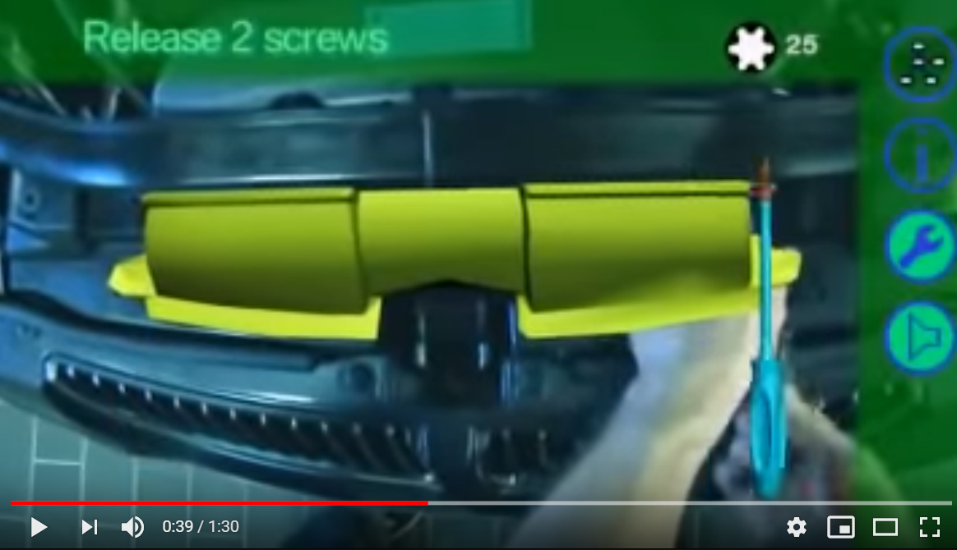

Figure 1: Screenshot taken from YouTube of the BMW Augmented Reality Car Repair App being used.

This screenshot shows a snippet of the BMW augmented reality car repair app video. You can see that a car component has been highlighted in yellow which indicates that the user must repair that component. The use of the AR smart glasses has allowed the user to repair the car component freely as they don’t need to worry about holding the device in their hands.

At the moment only engineers that work for BMW are experimenting with this technology and it has helped them maintain their car engines and find out any issues their cars encounter (Levski, 2018). But with a bit of work, BMW could release this AR technology for their customers so that they can repair their cars themselves. But then again, this AR technology is very complex and will likely be expensive to purchase.

**2.3.4 I-Mechanic AR Application**

I-Mechanic is an augmented reality application which allows users to learn how to perform simple repairs on their vehicles. Some people that own a car or have access to one, don’t have the knowledge on how to maintain cars which is why they tend to experience problems with their car. If car owners don’t maintain their vehicles properly then over time the car will start to encounter issues which can damage the cars components and risk put the driver’s health at risk. But the developers of I-Mechanic believe that their AR application will literally help anyone “to contextually access the instructions required to maintain their car, where is needed when is needed” by using an “innovative computer vision 3D tracking software” (“I-Mechanic, the AR App that turns”, n.d.).

This AR application can be used through a smartphone as it requires a camera to be able to use the augmented reality features. The application will display labels over each car component, so the user knows what each part is identified as. Also, there are animations that show the user how to perform a maintenance task such as refilling the engine coolant. If the user doesn’t have the tools or parts to perform a repair task, the application luckily has a feature that displays the nearest auto parts and repair stores, so the user knows where to go to purchase the parts. This is a great feature as the user doesn’t need to go through the hassle of closing the application to search for local auto parts stores on their web browser. The AR application can do it all in one platform. This simply makes the users experience much easier and the application itself will look more compact. However, this AR application will only work on a few car models which are a disadvantage for users that don’t meet the requirements of the application. The developers have mentioned that they would be expanding their AR application by storing more different car models so that more customers will be able to use the application (“I-Mechanic, the AR App that turns”, n.d.).

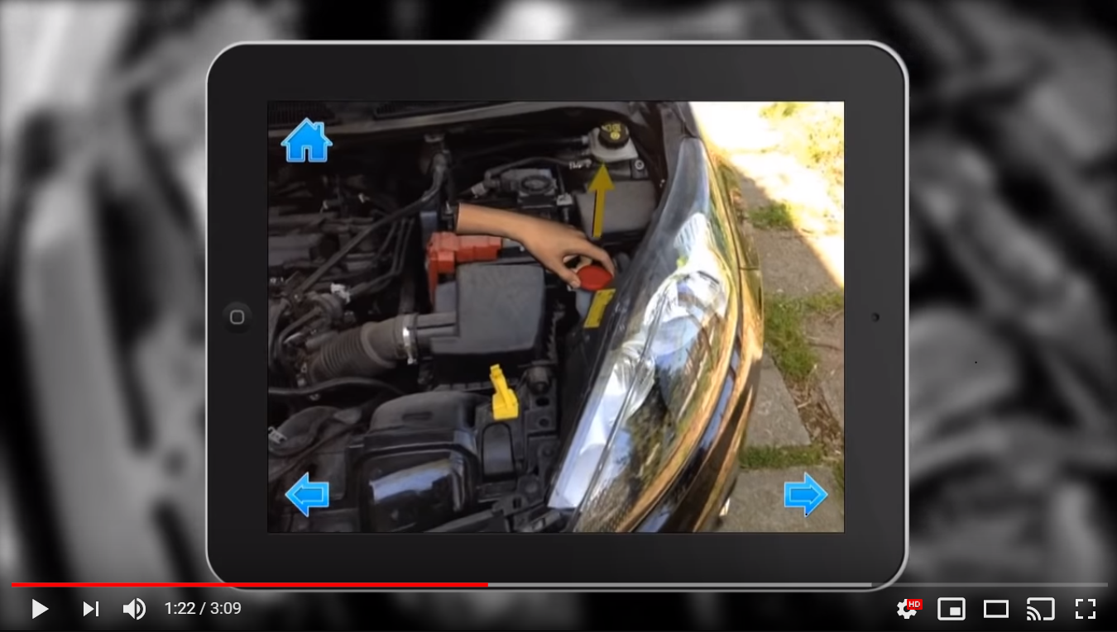

Figure 2 Screenshot taken from YouTube of the I-Mechanic AR application being used.

This screenshot shows you how the I-Mechanic looks like in action. You can see that there is a 3D model animation demonstrating the user how to perform a repair task. This animation is played in a loop so that the user gets to see it repeatedly and understand what the application is teaching them. However, sometimes animations cannot be clear even if you replay them several times. So, it would’ve been better if this application had some text above the animation, explaining what the user has to do or there could be sound playing in the background where someone is talking through the steps.

I-Mechanic has buttons within its interface so that the user can navigate through the application. For example, there is a home button to allow the user to go back to the start, there is a go back arrow button which allows the user to go one step back and there is a go next arrow button which allows the user to move onto the next step when there confident to do so.

**2.4 Technology Research**

**2.4.1 ARKit 2**

ARkit 2 is a framework designed by Apple which allows developers to design and create augmented reality applications for Apple devices such as iPhones and iPads (Fitzsimmons, 2018). ARKit 2 has become more advanced since Apple initially introduced ARKit 1. It has made it simpler for developers to create their AR applications by doing all the difficult tasks for them. For example, ARKit 2 makes use of the iOS devices camera to scan images, real-life objects in the environment and help position virtual 3D models in real-world space and accurately estimate its measurements so that the 3D model fits perfectly (Axon, 2018).

When the ARKit was first introduced, it focused on performing three essential tasks such as tracking, rendering and scene understanding. The ARKit uses rendering to deal with large tasks such as placing a virtual 3D model of a sofa into the real world. But for scene understanding the ARKit scans the surroundings and delivers information about it to the user. For the tracking part, the ARKit uses two types of tracking such as orientation tracking and world tracking. Orientation tracking is used to help developers to create AR applications which require the user to focus on real-life objects that are far out. This is achievable because the “ARkit uses the devices internal sensors to track rotation in three degrees of freedom” which in other words it’s like turning or rotating your head without physically moving other parts of your body. So, orientation tracking won’t work if the devices physical position is changing frequently (Axon, 2018).

World tracking works similar to orientation tracking, but the difference is that world tracking is able to track each time the device’s camera orientation changes and track the devices change in location. Even if the devices physical position were to be changed by a few meters, the ARkit will easily pick up on this and track it. There is more to the ARKit’s world tracking feature like for instance, it uses inertial odometry which is a process of recognizing key physical features within the environment. The physical features are captured from several angles whenever the device's camera is changing position or orientation. The features that are captured are put together to get a better understanding of the depth (Axon, 2018).

**2.4.1.1 ARKit 2 new features**

There are a variety of new features that Apple have implemented into their latest augmented reality framework. Below are some examples of the main features within the ARKit 2 that are being used by many developers.

**2.4.1.2 Shared AR Experiences**

This framework feature allows two or more users to view the same AR scene at the same time using separate Apple devices. Each user can interact with the augmented reality scene and whenever one user makes a change in the AR scene, the other connected users will be able to see that change but from their own perspective. Although this feature is new and can be difficult for newbies to implement onto their AR application, there is assistance online such as demos on how to implement shared AR experiences (Simone, 2018).

**2.4.1.3 USDZ File Format**

The ARKit 2 has a new file format known as USDZ which designed to specifically hold 3D content. When developers are creating their AR application they are required to design and make AR content using software like Photoshop CC. But to see how the AR content will look like in reality can be difficult. But with the use of USDZ, Apple has made it easier for the developers to view the AR content in the real world so that the developer can see how it looks like from their perspective. The developer will be able to make decisions on how well the AR content has turned out and if the content isn’t as good as they expected, they can simply just edit it. In addition to that the USDZ file format stores AR content as an encrypted zipped archive but at the same time it doesn’t compress any of the content within the file. So, the file stays protected, and the developer can decide if they want to share the file’s content with other developers that are using iOS devices or even macOS devices (What is "usdz", 2019).

**2.4.1.4 Environmental Texturing**

Environment texturing is a newly introduced feature within the ARKit 2. Apple has been using machine learning methods to make AR object look more realistic by using environment texturing to predict reflections, shadows, lighting and many more. At the moment if you were to create an augmented reality application that contains AR objects such as a shiny metal cup on a wooden desk, the wooden texture wouldn’t reflect in the shiny metal cup. But with the use of ARKits 2, the environment texturing will easily identify details in the surrounding physical textures which in the end, it will apply the details to the virtual AR objects (Davies, 2018). So, in this case, the shiny metal cup object that is placed on the desk would somewhat reflect the wooden texture of the desk and if you were to place a blue pen next to the shiny metal cup, you’d see a blue reflection from the metal cup. The use of environment texturing will definitely make the users AR experience feel more real because of the attention to detail on the way that the AR objects are displayed. The more accurate the reflections or shadows of the objects are then the closer it would look like to the real thing.

**2.4.1.5 3D Object Detection**

3D object detection is one of the most popular features in ARKit 2. Developers are able to use the ARkit 2 to scan all side and angles of real-life objects and import them into their AR application. Whereas in the old ARKit, users were only given the option to scan 2D objects which is pointless because a majority of real-life objects are in 3D.

**2.4.2 Swift**

Swift is a compiled programming language designed by Apple to allow developers to create applications. However, Apple has designed this programming language to only work on Apple systems such as Linux, watchOS, macOS and iOS (“The Good and the Bad of Swift”, n.d.). This factor had to be taken into consideration when creating the *Car Mechanic AR Application* because it would mean that the target audience would require to use an iOS device in order to have a go on the AR application. But going back to what Mr. Hayman said about the college allowing their students to borrow iPads, it solves the problems for students in the motor vehicle course that don’t own an iOS device themselves.

Ever since Swift was created in 2014, the programming language has become one of the most popular programming languages for developers to sue. One reason being is that the syntax has been intelligently designed to help developers create clean code, so it is easier for them to read and for the other developers that have access to the code. This is achieved by using safeguards which helps prevent errors within the code. Another reason why Swift is a popular programming language for developer is that it encourages a faster development process when creating applications. For instance, if you wanted to implement a login system using a programming language such as object-c, the code could be hefty and long to implement but with Swift, the implementation for the same task will be shorter which will save a lot of time for the developer to do other tasks.

Creating applications using Swift can benefit the developer in the long term especially if the application is for an ongoing project. Apple is always looking for ways of adding new features to Swift where it’s needed, so by creating applications using this programming language, it will mean that you’ll be able to access new features and you don’t need to worry about swift being outdated. This is one of the main reasons why the *Car Mechanic AR Application* was created using Swift as it can be worked on regularly in the future.

**2.4.3 3D scanning app**

Like mentioned previously the ARKit 2 allows users to scan real-world objects and detect them. But this task can be very difficult for someone to implement themselves. So Apple has created a 3D augmented reality scanning application to allow users to scan and detect their objects effortlessly. This 3D scanning app is an add on to the ARKit 2 so its optional for developers to download it. But since this project requires the *Car Mechanic AR Application* todetect car components and display information about them, it is essential to use this 3D scanning application to achieve that goal.

The process of using this 3D canning AR application is that you first have to install it onto an iOS device that has a back camera and good hardware specs, otherwise you will experience issues when using the app. Once the application is downloaded on the device the user is required to open it up and follow the instructions. The instructions are fairly simple so there is no reason in not being able to scan an object. However, there are some things that can cause the application to not work properly. For example, the 3D scanning AR application doesn’t work well in unlit areas because it cannot see the detail on the objects. So, it is important that the objects are placed in an area where there is enough lighting for the camera to pick up every single bit of detail.

Sometimes if the object is very small the 3d scanning application may not be able to scan it even if there is enough lighting in the background. The reason for this is because application struggles to focus on very small details and therefore may not allow the scan to been successful. But in some cases, the application can scan small objects but when it comes to detecting the object it can take a while to identify it or it may not even detect it. So, in this scenario, it's best to make sure the object is rescanned and test if it can be detected.

When using the 3D AR scanner app for the *Car Mechanic AR Application* it is important that the scanned objects are easily detectable. So, the best thing to do is scanning car components that are big enough for the 3D scanner app to capture all the details of the component.If this process isn’t done properly then there will be issues when the *Car Mechanic AR Application* is being used to identify the car components. The overhead labels won't display over the car components which would be a massive downfall to the users AR experience.

**3 System Design**

With every successful application, a design process is made before starting the implementation. The design stage is important as it allows you to plan how the application will work so that it prepares you for the implementation stage. The design stage could also include drawing or prototypes of how the application will look like so that the developer can work towards that. Before implementing the *Car Mechanic AR Application* some designs were created such as a diagram showing the overview of how the application works and a storyboard showing the process of how the user is expected to use the application.

**3.1 System Requirements**

There is a set of requirements that the *Car Mechanic AR Application* is expected to meet in order for the project to be successful. Below is a list of requirements that have been set for the *Car Mechanic AR Application* and these requirements can be checked whether they were completed during the testing phase. The testing phase will show if there were any failures with the *Car Mechanic AR Application* so that they can be corrected in the future.

***3.1.1 Car Mechanic AR Application* Requirements**

* Allow user to open the *Car Mechanic AR Application* without causing the application to crash.
* Allow user to access their device's camera so that they can use the feature from the *Car Mechanic AR Application.*
* Display the correct overhead labels for each car component the user device focuses on.
* Display the overhead label information in a double-sided format so the user can read the information on both sides.

**3.2 System Process Diagram**

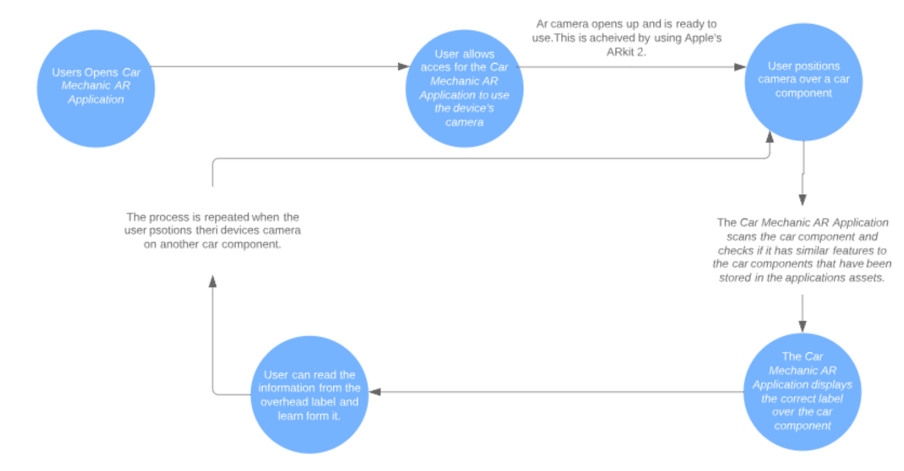

In this figure, it shows a diagram of how the *Car Mechanic AR Application* will work. The first stage begins with the user opening up the *Car Mechanic AR Application.* The second stage, the user is prompted with a message box as soon as they load up the *Car Mechanic AR Application*. This message asks for the user’s permission to allow the application to access the camera of the device. If the user denies the request, then the application will not offer the AR experience for the user. But if the user accepts the request then the AR camera will instantly open up so that it's ready to use. The third stage requires the user to physically position the device’s camera over a car component. They have to make sure that they hold the device firmly and keep it steady so that the AR camera can focus on the car component. The reason for this is so that the AR camera can scan the car component and check whether it has a label for it. If the car component the user is trying to identify is stored within the *Car Mechanic AR Application’s* assets, then it will display the overhead label for that specific component. The fourth stage is displaying the overhead label with the correct information. Once the user has seen and read the information from the label then they can repeat the process of identifying the car components but on a different component.

The good thing that the *Car Mechanic AR Application* does is that when it displays the labels and the user tries to identify another one, the previous label still stays in the same physical position as the other component so if the user wants to go back to it they don’t need to repeat the process of trying to identify the component. If the user decides to move the components physical position, then the overhead label will follow its direction.

**3.3 System Storyboard**

With the information gathered from the research, A storyboard was created to show how the *Car Mechanic AR Application* will operate. This is similar to what was shown form the system diagram but the difference here is that a storyboard is a sequence of hand-drawn or digital sketches which illustrate how the application works. The storyboard contains several screens which shows what happens in each event and how it would look like form the user’s point of view. The storyboard can be used as a tool to show the client roughly how the application would look like before starting the implementation stage. If the client is happy with what the storyboard is demonstrating, then it's reasonable to start implementing the application.

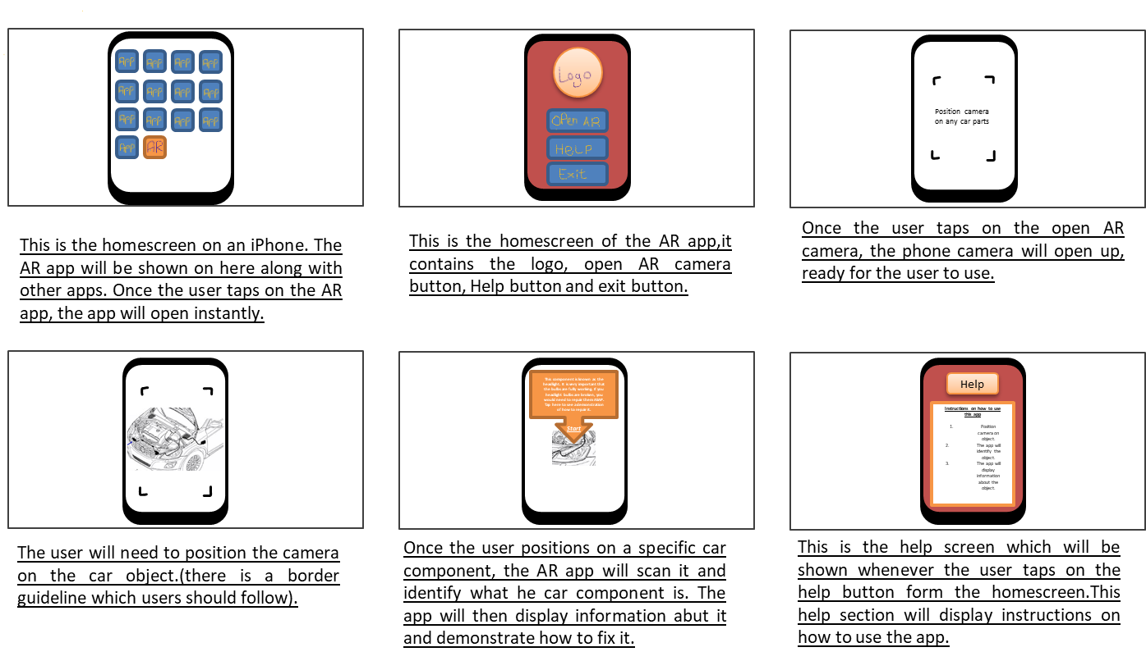

The figure above shows that storyboard created for the *Car Mechanic AR Application*. As you can see that the storyboard has a series of splash screens which show snippets of what happens when the user is using the application. This storyboard was shown to Mr. Hayman so that he gets a better view of how the *Car Mechanic AR Application* works and so he can provide feedback on it. He mentioned that he now understands how the application is meant to operate as he wasn’t entirely sure what the application would be like from the first meeting. The is mainly because of the digital sketches, they were simple and clear to understand. Besides its easier to understand information when it is presented through images or sketches.

So, since Mr. Hayman has approved the storyboard for the *Car Mechanic AR Application,* it makes sense to use it as a guideline for when it comes to the stage of implementing the AR application.

**3.4 Overhead Label Design**

The overhead label is probably the most important feature within the *Car Mechanic AR Application* as this is meant to provide all the information for the user to learn about car components. So, knowing this it was vital to design how the label would look like in terms of font style, font colour, font size, and many other features. The overhead label design must be thought through carefully so that the implemented version can look appealing to the users.

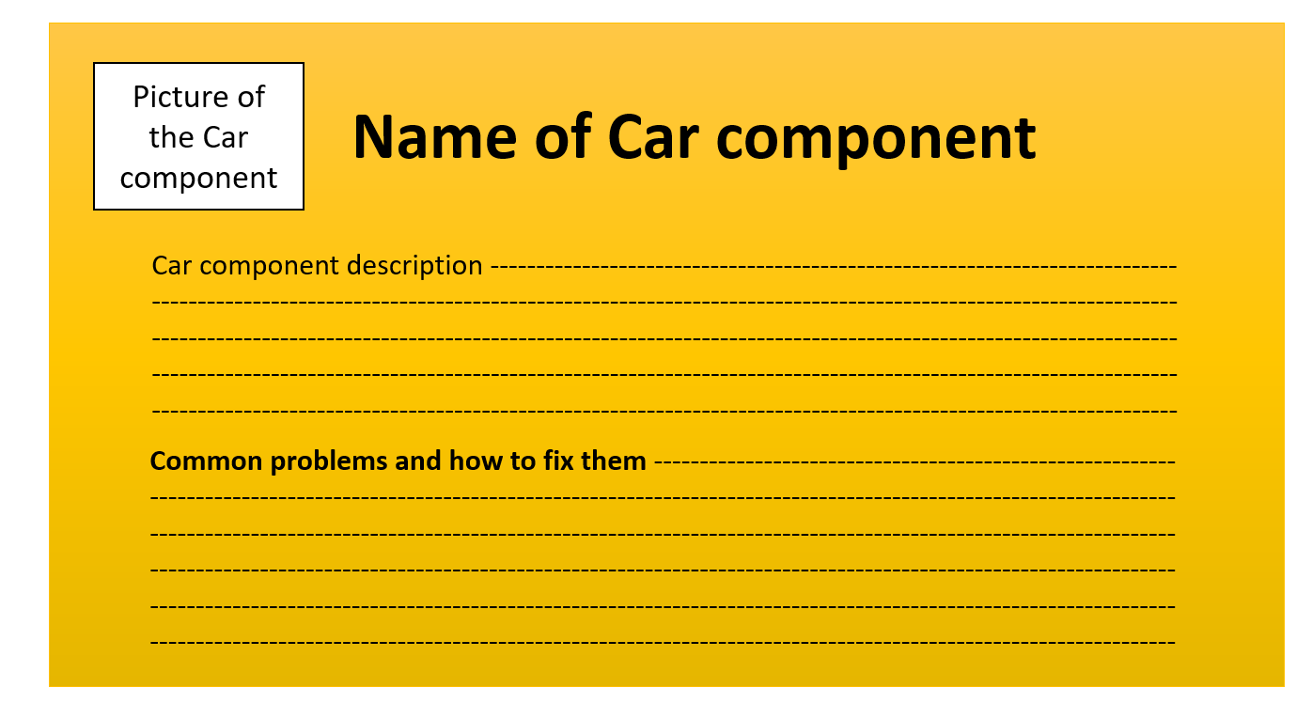

The figure above shows the general layout for all the overhead label designs. As you can see that the design has a title which identifies the name of the car component. The title font colour is in black since it is the most useable colour to use for text and the font style is in bold so that the title stands out from the other features within the label.

The overhead label design contains a picture on the top left-hand side of the label. This picture will represent what the car component looks like. By adding a picture in there, it makes the overall label look more interesting rather than just loading the whole label with information. Also, it is important to have a picture of the car component in the label so that it verifies the scanned component. For instance, when the user is trying to scan a car component and the label appears above with the picture of the real-life scanned component, it would prove to the user that the *Car Mechanic AR Application* has successfully displayed the correct label for the component they’ve scanned.

Another feature within the overhead label design is the information. The information just under the title describes what the identified car component is and what’s its purpose. The font colour for this information would be black so that it matches the same colour as the title and other headings. The label wouldn’t look appealing to the eye if it had numerous of different coloured text and it certainly wouldn’t look professional.

There is a subheading in this overhead label design which displays information about the common problems that can occur with the identified car component and possible ways to fix those problems. This subheading font colour is also in black and it has a bold style applied to it so that it stands out from the other text. However, the font size for this subheading is slightly smaller to the main title because of the general format for headings and subheadings for any piece writing. For example, newspapers always have a title which has the largest font size on the page and the subheadings are slightly smaller. The first thing the user will notice is the title then they notice the subheading.

All the features within overhead label design are placed in a rectangular container so that it holds all the content together. The container has an orange background colour because it is an eye-catching colour and the user will be able to notice it from a distance. Also, since the heading, subheading and information text is in black, it will stand out more in the orange background which in result it will make it easier for the users to read.

**4 Implementation**

This section focuses on the implementation of the *Car Mechanic AR Application.* The implementation stage is split into three different parts. The first part is using the 3D scanning application provided by Apples ARKit 2 so that the car components can be scanned. The second part is creating the overhead labels on XCode using the sprite kit scene and the final part is implementing the overhead labels so that they appear over the car component the user is trying to identify. This can be achieved by using the ARKit 2 and Swift programming language.

**4.1 Scanning the Car Components**

Like mentioned earlier in the report, it was essential to work with the car components from the local college's workshop cars because those are the vars the students tend to do their work on. So, it is important to scan the car components first and test whether they’ve been scanned properly or not. To achieve this, XCode was used to compile the 3D scanning application onto an iOS device such as an iPhone X because it has a camera which is required in order to scan real-world objects.

Whilst using the 3D scanning application to scan the car components from the local college, there were some difficulties trying to scan some of the car components. Some components were hard to get to because of the way they were positioned. Some of the car components were too deep into the vehicle and were blocked by cables which made it impossible for the 3D scanning application to work effectively. So, for this reason, only car components that are visible from all angles were chosen to be scanned. There were some components such as the brake disc which had a lack of lighting on them and made it very difficult to scan them because the 3d scanning application couldn’t see enough detail from the object. Although there were issues with scanning some cars components, there were some components that got scanned successfully such as the engine oil tank, engine coolant, screen wash reservoir, brake fluid tank, battery and headlight bulbs. These car components were successful in the scanning process mainly because they were large enough for the 3D scanning application to focus on. Also, the details on these car components are different from other components which makes it easier to detect them.

**4.1.1 Scanning Process**

Below shows a series of steps backed with images showing the scanning process for the car components.

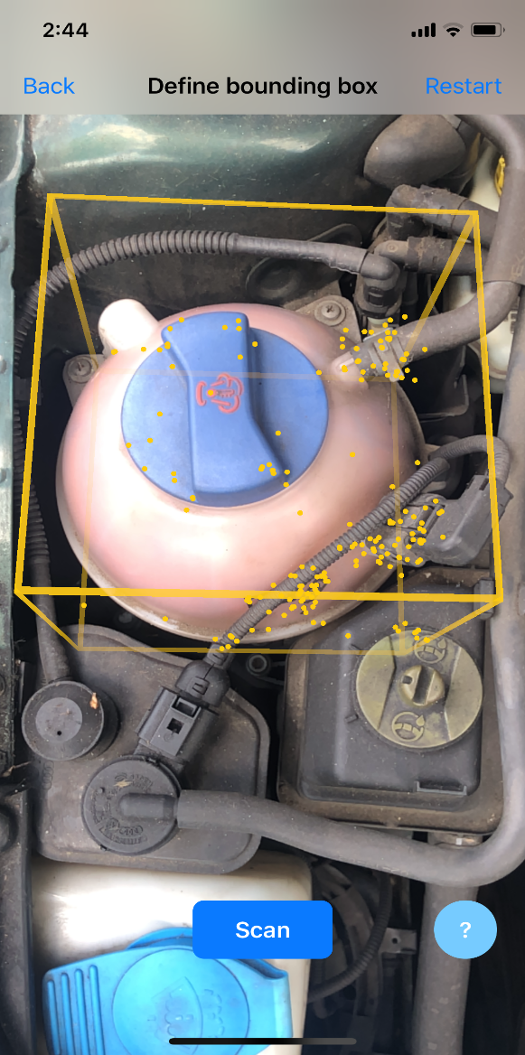The first step was positioning the iOS device’s camera over the car component that is intended to be scanned. As soon as the camera is steady the 3D scanning application displayed a small yellow AR cube container which is used to place it over the object. The yellow cube had to be resized so that it fitted the over the whole car component.

This figure shows a screenshot of the 3d scanning application being used on a car component. As you can see that the yellow AR cube container has been placed over the engine coolant. The yellow dots that appear on the container indicates that the position of the container is set in place and all that needs doing is to click on the scan button which proceeds on to the next step.

The second step is probably the main tricky step and requires some physical work. This step is where the scanning process happens. In this step, the yellow AR cube container is locked in place so that the car component is ready to be scanned and its physical position cannot be moved whilst scanning. When scanning the car component, it requires time and stability to slowly move the device’s camera around each face of the yellow AR cube container. The reason for this is so that the 3D scanning application can capture every detail from the car component.

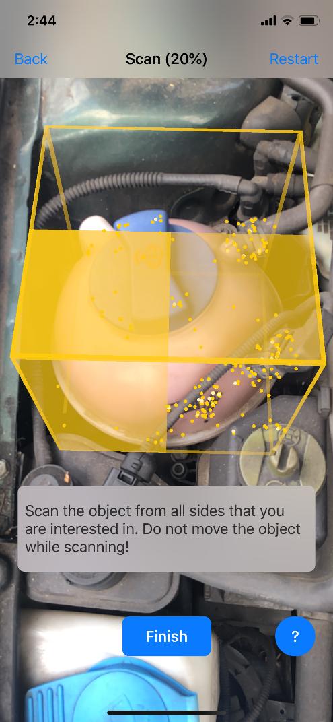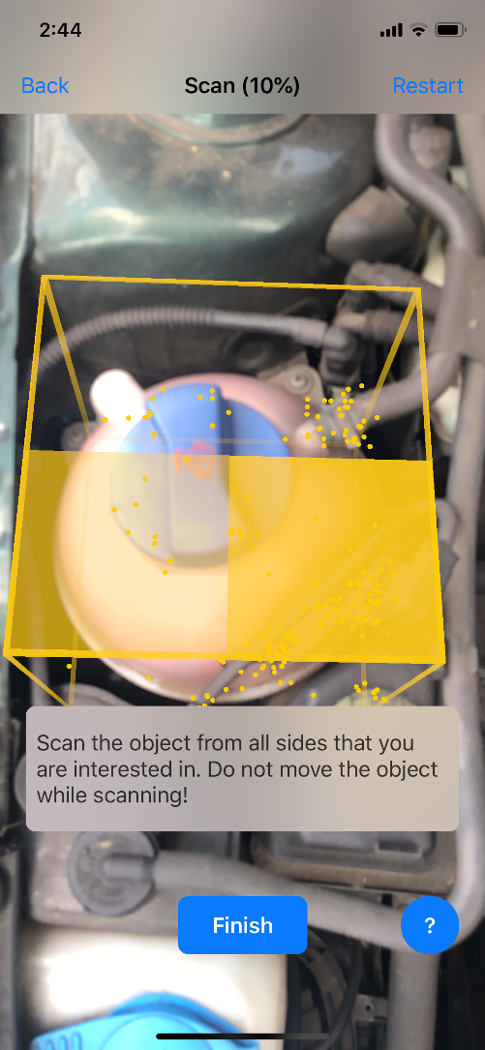

The figures above show the engine coolant getting scanned. As you can see that the engine coolant car component is being scanned and for each section of detail that gets scanned it is filled in yellow. The reason for this is so that it confirms that the section has successfully been scanned. On top of the 3D scanning application, it shows how much of the object has been scanned in percentages which are very helpful as it lets you know about the progress of the scanning. In order for the scan to be complete, all sides of the car component need to be scanned until the progress reaches 100%. So as soon as the whole car component was scanned, the finish button was clicked so that it finalizes the scan and then the testing stage begins.

The third step involves testing the scanned car component to see whether it was successful or not. This step is fairly simple, all it requires is to click on the test button and the 3D scanning application will do all the testing on its own.

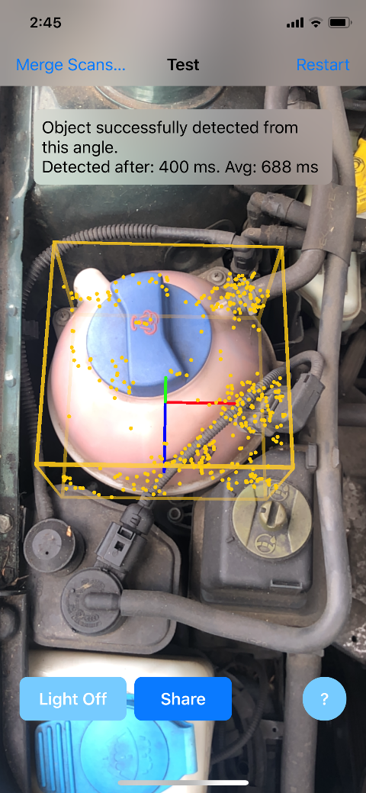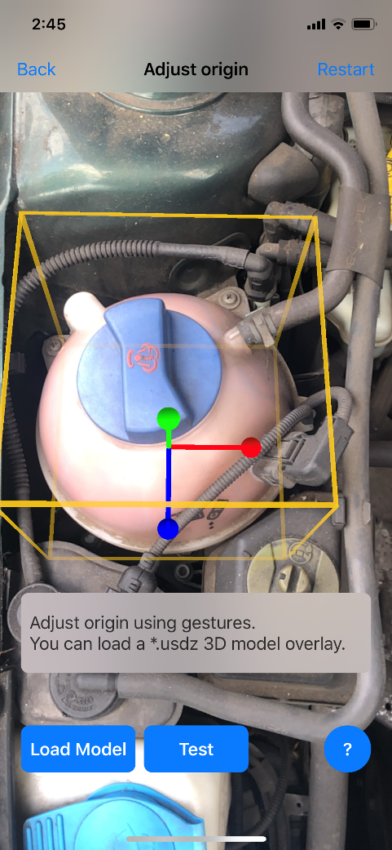

These figures show a before and after the process of the testing stage. As you can see that once the test button is clicked the 3D scanning application tests the car component that was scanned and tries to detect it. This process usually takes a few seconds, but it can take longer depending on the size of the scanned object.

If the test is successful, the 3D scanning application will display a message such as “Object successfully detected from this angle”. The car component was tested on all angles so that it verifies that the car component can be detected. If for any reason the 3D scanning application isn’t able to test the scanned car component it will notify you saying that there isn’t enough detail to detect the object and therefore it would require restarting the whole scanning process from the beginning.

The final step for this scanning process is to save the scanned component onto the *Car Mechanic AR Application’s* assets folder. This was achieved by clicking on the share button and then selecting the Airdrop method so that it can be sent to the MacBook device that has the *Car Mechanic AR Application* project folder.

**4.2 Creating the Car Component Labels**

Creating the car component labels are important as it is one of the requirements and these labels are what the users are expecting to see when using the *Car Mechanic AR Application.* In order to create these labels, it is essential to use an app development platform such as XCode. This platform will enable to use of the ARKit 2 and all its augmented reality features. For every component that was scanned, some research needed to be done in order to find out the required information such as what the component does, what types of problems can occur and how to fix those problems. Also since the format for the label design requires an image of the car component, a picture of every car component was taken during the scanning stage.

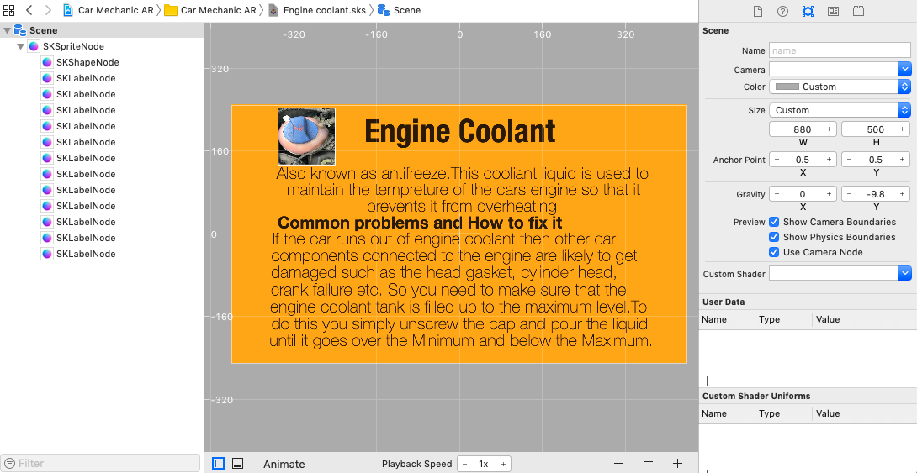

The figure above shows how the engine coolant label looks like when its created in XCode. As you can see that the label layout and colour look exactly the same as the label format that was created in the design stage. The label contains information about the car component, and it has the correct picture of the car component attached to it.

There was a series of steps for the creation of the car component labels. The first step involves creating a sprite kit scene so that the label can be created inside it. The spriteKit scene acts as a canvas and it allows you to insert shapes, buttons, labels, animations and many more.

The second step involves setting up a custom size for the labels spriteNode so that all the required content can fit inside it. The width of the sprite node is 880 and the height is 500 which transforms the sprite node into a rectangular shape. This size is applied to all the other car component labels so that overall it looks more consistent. The *Car Mechanic AR Application* would look odd if the overhead labels had different sizes.

The third step involves creating all the content required for the label. So, the first thing that was done was the orange background as it is the base of the whole label and it is easy to notice what is inserted over it. The next thing that was added, is the title which in this case it would be called the engine coolant. The title is bold and has a large font size so that it is noticeable by the users even at a long distance. The next thing that was created was the research information that was gathered about the car component. This information is condensed into sperate labels so that they can fit into the sprite node. Lastly, the final process was to insert a picture of the engine coolant into the sprite node. The only way to achieve this is by inserting a shape like a square and then changing the texture of the shape into the picture of the engine coolant.

The process for the creation of the engine coolant label mentioned earlier was used to create the label for the other car components. The screenshot for these car component labels can be found in Appendix A.

**4.3 Implementing the labels on the Car Components**

The only way to implement the labels for the car components is by using theSwift programming language. In addition to that, there were some libraries that were required so that AR features can be implemented onto the *Car Mechanic AR Application.* Below shows the implementation process for the engine coolant car component but the other car component implementation can be found in Appendix B.

The first thing that was done for the implementation is to import the required libraries such as the UIkit, SceneKit and most importantly the ARkit. These libraries are essential since they enable feature such as using AR objects and sprite scenes which the *Car Mechanic AR Application* will be using. The screenshot below shows the code for the viewController.swift. Here the *Car Mechanic AR Application* has been programmed to load an empty scene for every time the user opens the application. Usually whenever you try to create an AR application using the ARKit, the scene would normally have some sampled AR objects which would appear each time the application is booted. But for the *Car Mechanic AR Application* the default contents within the scene were all deleted as those AR objects aren’t relevant to the project requirements.

The scene has been programmed to show statistics such as fps and timing information. These statistics will help the user know the performance of the *Car Mechanic AR Application.* For example, the *Car Mechanic AR Application* would show that it is running at 60fps which is the normal performance it runs on when the application is being used. But if the user experiences some lag when using the application then the fps statistic will show that it has dropped.

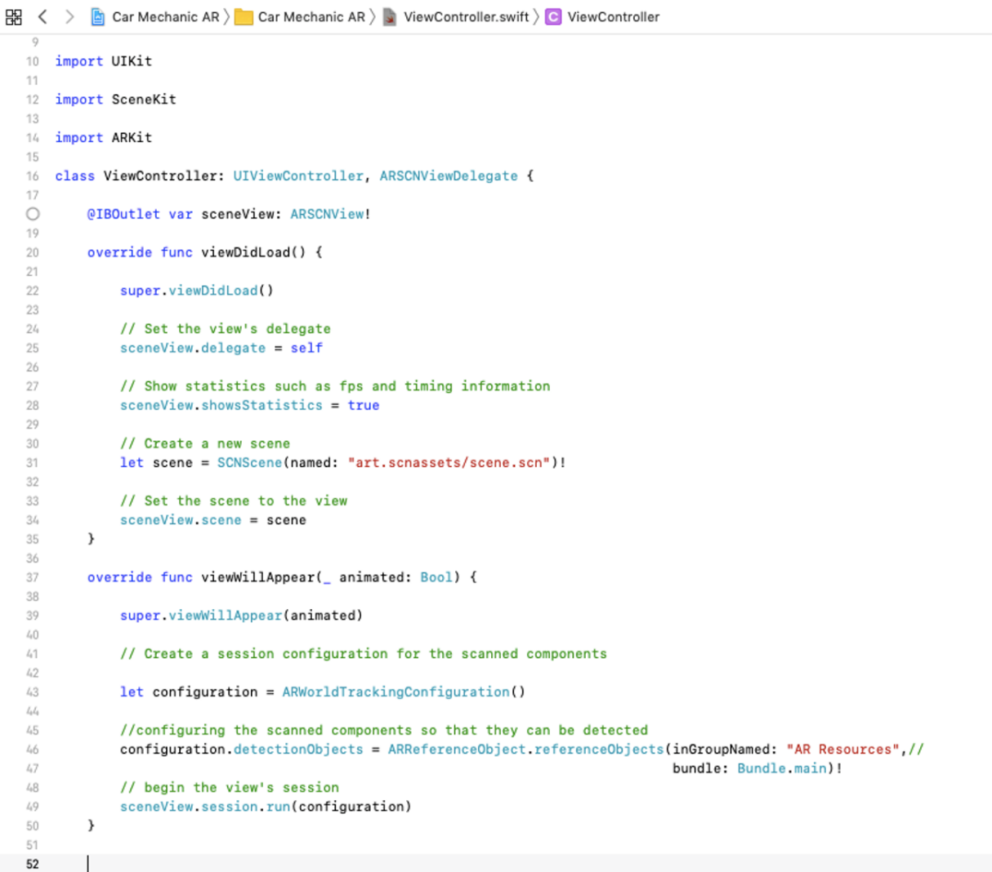

The second part involves configuring the scanned car components so that the *Car Mechanic AR Application* can detect them. The code below shows some properties being configured such as the ‘detectionObjects’. These properties are essential as they initiate the detection feature. But in order for the *Car Mechanic AR Application* to detect the car components, the application needs a reference source to retrieve all the components. So, by using ‘referenceObjects’ it allows the *Car Mechanic AR Application* to collect the scan models from the assets folder which in this case is called AR Resources. Each time the application is being used to try and detect the car components; it would instantly look inside the AR resources folder to find them.



The third part is where most of the work occurs. In this part it is required to create an Anchor which is a Swift delegate function that returns a SCNNode. This Anchor is created whenever the Car *Mechanic AR Application* detects a car component. But the anchor requires a node so that the Spritekit scenes that contain the labels can be put onto the nodes.

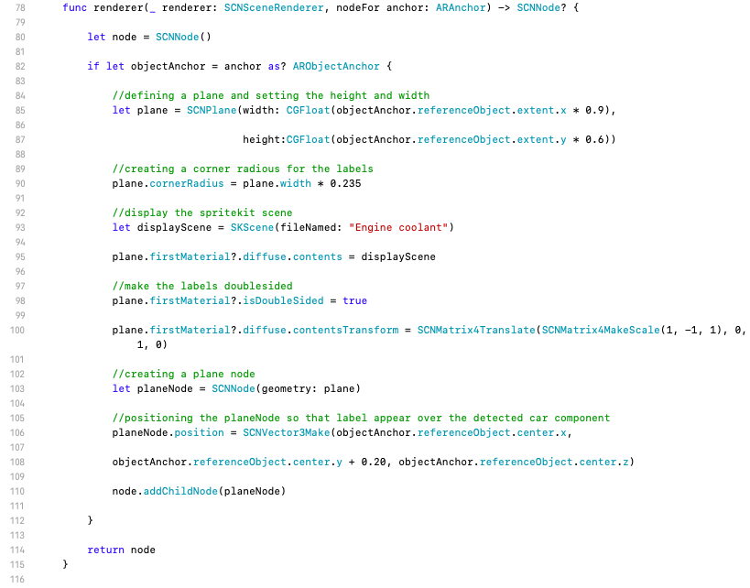

The screenshot above shows the Anchor being created and there is a node attached to it. At this stage, this Anchor is empty as it doesn’t have any properties set for it.



The next step is to check if we can get an AR object as an Anchor. This can be achieved by using an if let statement to try and use the anchor that is received as a parameter and cast it onto an ‘ARObjectAnchor’. The ‘ARObjectAnchor’ contains transform information and it also contains the ‘referenceObject’ so that the plane attributes such as the size can be defined.

The code above shows that a plane is created which is where the car component labels are expected to be displayed. The plane’s width and height are initialized and set to cover 90% of the detected component's width and 60% of the height of the detected component. The plane’s height and width could’ve been set to match the exact measurements of the detected car component, but it would’ve ruined the appearance of the labels when they’re are attached to the plane. The plane is given a corner radius so that all four corners of the label are curved which makes the label look more presentable.



The next step involves applying the engine coolant label onto the plane so that the plane contains all the information about the car component. The code above shows that the engine coolant Spritekit scene that contains the label is selected to be shown on top of the plane. The plane is also coded to have a doubled sided feature so that the label information is displayed on the front and back of the plane. This feature is useful as it will allow the user to read the information of the label from both sides. Since there is a difference in the engine coolant SpriteKit scene and the AR Scene, the plane’s transform is therefore required to be configured. So, in this scenario, the whole of the engine coolant SpriteKit scene is flipped vertically.

The final step of implementing the engine coolant overhead label is to create a plane node so that it can be set at a position where it hovers over the detected car component. The code below sets the position of the plane node over the detected car component. However, the ‘referenceObject’ y-axis is increased by 0.20 so that the engine coolant label is displayed 20cm above the detected car component.



As soon as all the other car components were implemented the way the engine coolant was implemented, the *Car Mechanic AR Application* had to be run so that verifies whether the implementation worked. If there were issues encountered, they had to be resolved before allowing the users to test the application.

**5 Testing and Evaluation**

Like with every system or application, it is important that every feature is tested thoroughly so that you can find out if there are any errors and start fixing them. The Car Mechanic AR Application was tested each time something was added to the implementation so that fewer issues are caused when testing the final product. There are two types of testing that were performed for this project such as black box testing and user testing.

**5.1 Black Box Testing**

Black box testing is an application testing technique which examines the functionality of the application without knowing much about the internal structure of the application being tested (Dotterweich, 2018). It compares the expected result with the actual result so that a decision can be made on whether the application’s functionality is successful.

Black box testing was performed on the *Car Mechanic AR Application* so that it validates whether the application has met the requirements or not. Black box testing is important to do before testing the application on the targeted users because so that if there are any errors then they can be fixed immediately. If the testing wasn’t done properly then it could be a disaster when the target audience is using the application.

|  |  |  |  |  |
| --- | --- | --- | --- | --- |
| **Description** | **Expected Result** | **Process** | **Actual Result** | **Pass Or Fail** |
| Test if the *Car Mechanic AR Application* opens up. | The *Car Mechanic AR Application* load up without it crashing | The user should tap on the *Car Mechanic AR Application* app icon. | When the user taps on the *Car Mechanic AR Application* icon, the application loads up and enables the user to use its features | Pass |
| Test if the *Car Mechanic AR Application* allows the users to access their device's camera | The *Car Mechanic AR Application* should prompt the user to enable their device's camera to be used within the application | When the *Car Mechanic AR Application* is opened, the user should click the OK button so that their camera is enabled. | The user’s camera is enabled and ready to use the *Car Mechanic AR Application* features. | Pass |
| Test to see if the *Car Mechanic AR Application* can detect the engine coolant car component. | The *Car Mechanic AR Application* will display the engine coolant label over the car component. | Position the device’s camera over the car component. | When the user positioned their device’s camera over the car component, the engine coolant label was displayed over the car component. | Pass |
| Test to see if the *Car Mechanic AR Application* can detect the brake fluid car component. | The *Car Mechanic AR Application* will display the brake fluid label over the car component. | Position the device’s camera over the car component. | When the user positioned their device’s camera over the car component, the brake fluid label was displayed over the car component. | Pass |
| Test to see if the *Car Mechanic AR Application* can detect the screen wash reservoir car component. | The *Car Mechanic AR Application* will display the screen wash reservoir label over the car component. | Position the device’s camera over the car component. | When the user positioned their device’s camera over the car component, the screen wash reservoir label was displayed over the car component. | Pass |
| Test to see if the *Car Mechanic AR Application* can detect the engine oil tank car component. | The *Car Mechanic AR Application* will display the engine oil tank label over the car component. | Position the device’s camera over the car component. | When the user positioned their device’s camera over the car component, the engine oil tank label was displayed over the car component. | Pass |
| Test to see if the *Car Mechanic AR Application* can detect the battery car component. | The *Car Mechanic AR Application* will display the battery label over the car component. | Position the device’s camera over the car component. | When the user positioned their device’s camera over the car component, the battery label was displayed over the car component. | Pass |
| Test if the engine coolant label is double-sided. | The *Car Mechanic AR Application* should show the engine coolant information on both sides of the label. | Detect the engine coolant component and move the device’s camera to the back of the label and check if there is information on that side. | When the user detected the car component, the engine coolant information appeared on both sides of the label. | Pass |
| Test if the brake fluid label is double-sided. | The *Car Mechanic AR Application* should show the brake fluid information on both sides of the label. | Detect the brake fluid component and move the device’s camera to the back of the label and check if there is information on that side. | When the user detected the car component, the brake fluid information appeared on both sides of the label. | Pass |
| Test if the screen wash reservoir label is double-sided. | The *Car Mechanic AR Application* should show the screen wash reservoir information on both sides of the label. | Detect the screen wash reservoir component and move the device’s camera to the back of the label and check if there is information on that side. | When the user detected the car component, the screen wash reservoir information appeared on both sides of the label. | Pass |
| Test if the engine oil tank label is double-sided. | The *Car Mechanic AR Application* should show the engine oil tank information on both sides of the label. | Detect the engine oil tank component and move the device’s camera to the back of the label and check if there is information on that side. | When the user detected the car component, the engine oil tank information appeared on both sides of the label. | Pass |
| Test if the battery label is double-sided. | The *Car Mechanic AR Application* should show the battery information on both sides of the label. | Detect the battery component and move the device’s camera to the back of the label and check if there is information on that side. | When the user detected the car component, the battery information appeared on both sides of the label. | Pass |

**5.2 User Testing**

User testing is another type of testing that was performed for the *Car Mechanic AR Application*. Once the application was completed and tested thoroughly, it was taken to a local college so that the students studying the motor vehicle course can test the application on the cars they do practical work on. They were asked to fill in a 2-minute survey which consists of 10 questions about their experience using the application and they had a section where they could give feedback about any improvements that can be made for the application. The full survey can be found in Appendix A.

User testing is beneficial as it helps evaluate the project’s success and find out whether the application was useful to the students or not. The feedback from the users can help to make future developments on the *Car Mechanic AR Application* so that it becomes more advanced and will attract more users to use it.

Below shows some of the results from the survey questions that were answered by the students. In total there were 19 students that tested the *Car Mechanic AR Application* but only 14 students volunteered to answer the survey questions.

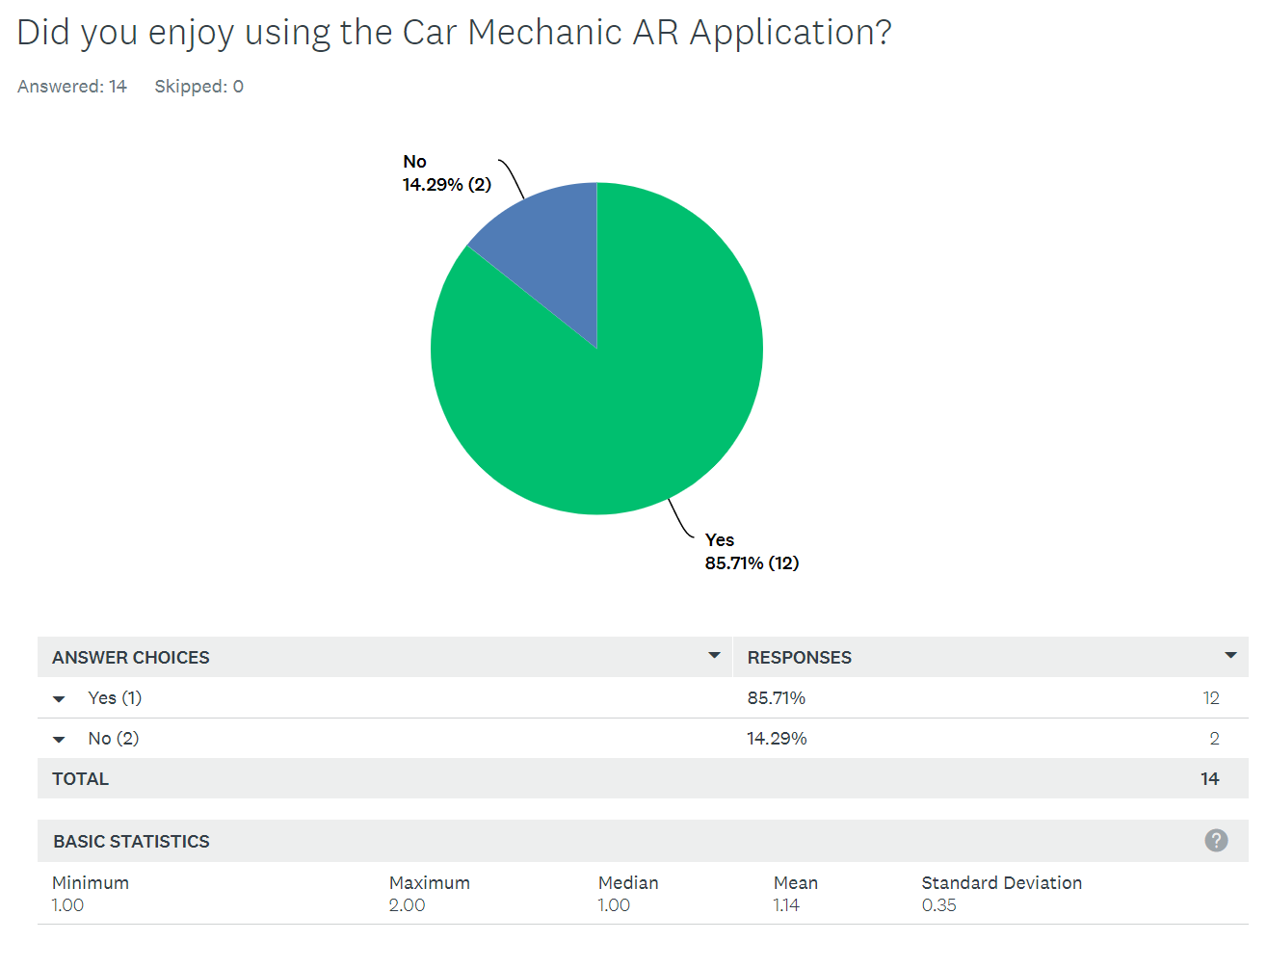

In figure 3 it shows that about 85.71% of students enjoyed using the *Car Mechanic AR Application* and 14.29% of students did not enjoy using the *Car Mechanic AR Application.* This indicates that the majority of students enjoyed their AR experience and possibly if the application was to be available on the market, they’ll most likely download it.

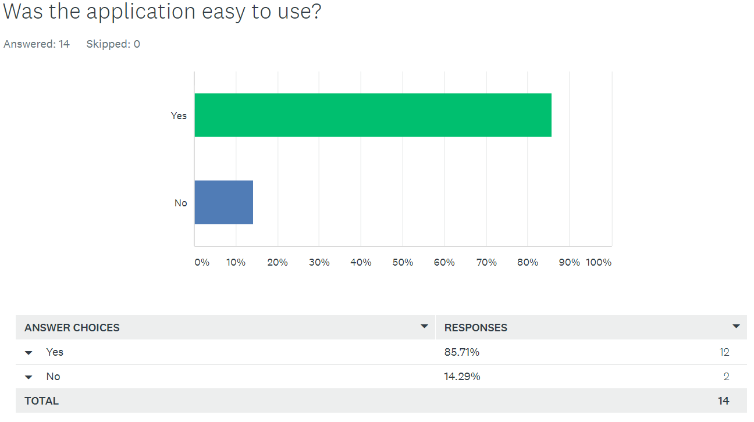

In figure 3.1 it shows that about 85.71% of students found the *Car Mechanic AR Application* easy to use and 14.29% of students didn’t find the application easy to use. This indicates that the *Car Mechanic AR Application* offered most of the students a simple and easy AR experience which is a good thing because people tend to enjoy doing tasks that are genuinely easy to complete which means they’re more likely to use the application again. So, since most students found it easy to use the application, you could say in this case it was successful.

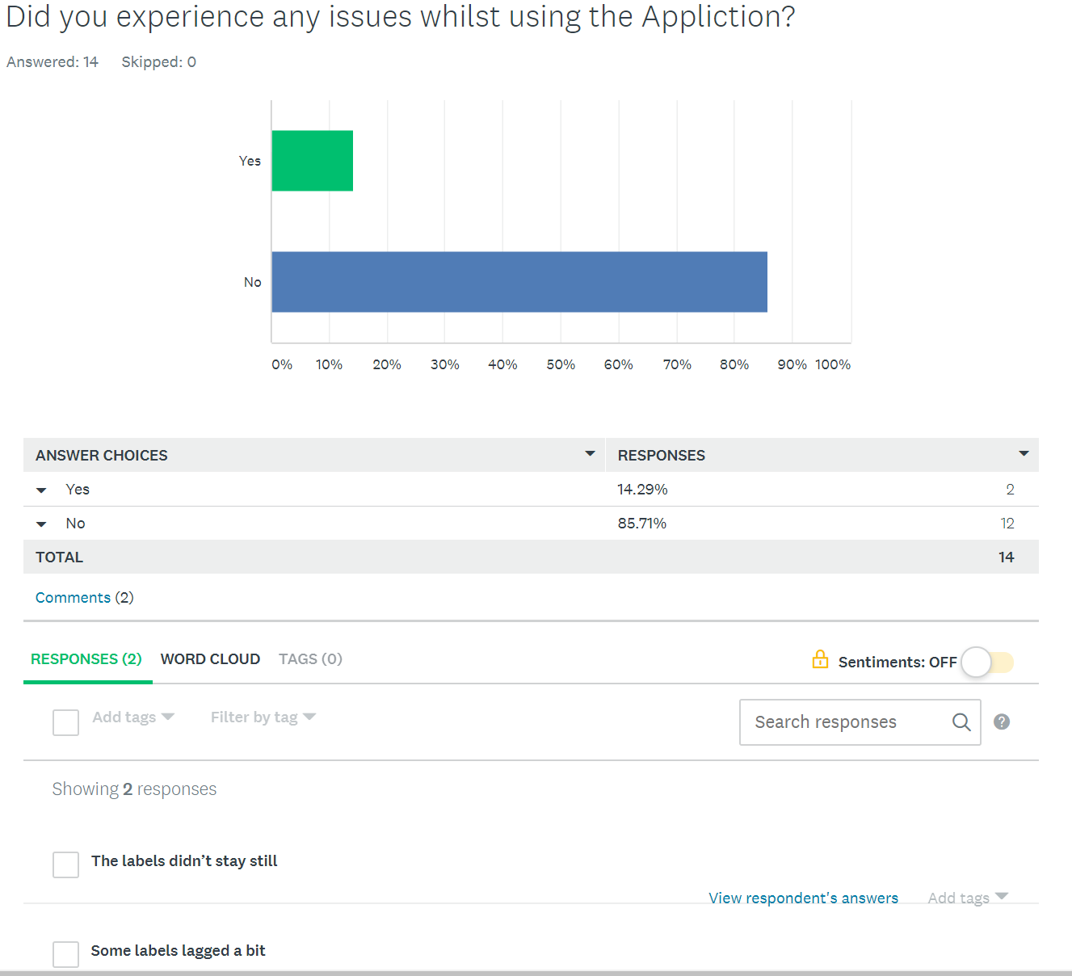

In figure 3.2 it shows that about 85.71% of students didn’t encounter any issues with the *Car Mechanic AR Application* but there was about 14.29% of students that did experience issues with the application. The issues that were raised was that the labels didn’t stay still. The cause of this could be that the student may have been moving the device around too much which causes the labels to not stay in their position. The device is required to stay steady but if the user wants to move the device, they’ll have to do it slowly so that the position of the label doesn’t mess up. Another issue that was raised by one student was that some of the labels were lagging. The reason for this could be, that the application’s frames per second may have dropped which cause a lot of lag. The only way to fix this issue is by reopening the *Car Mechanic AR Application* and the frames per second should restore back to normal. But apart from these minor issues, a majority of the students didn’t encounter any problems with the application.

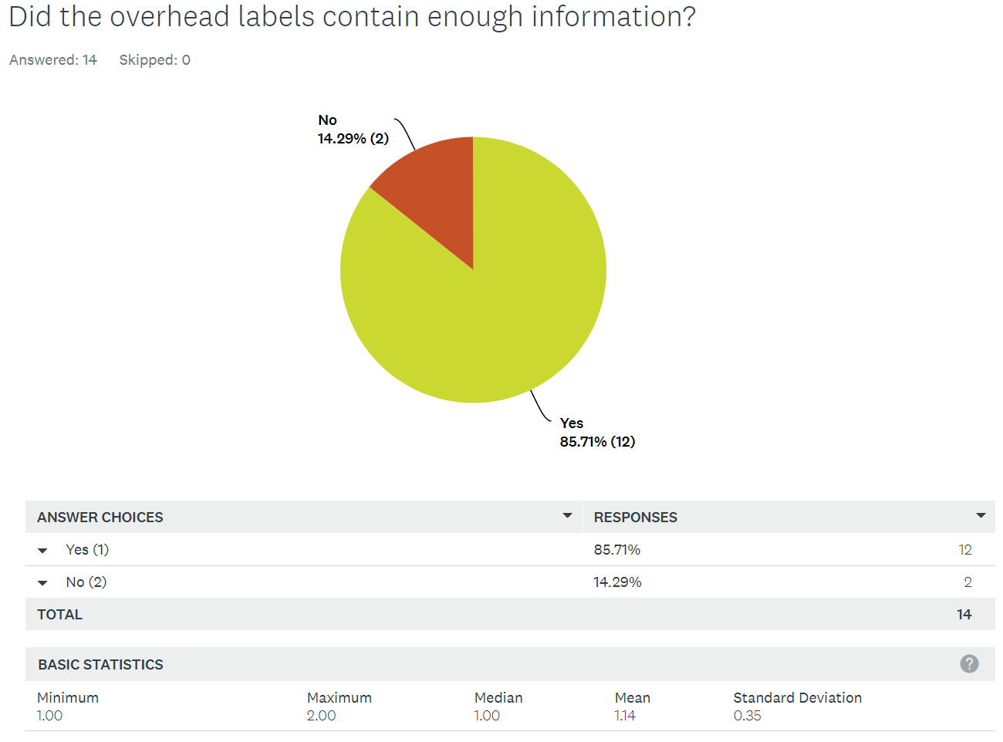

In figure 3.3 it shows that about 85.71% of students found that the overhead labels in the *Car Mechanic AR Application* contained more than enough information about the car components. But 14.29% of students didn’t feel like there was enough information in the labels. Although they might have felt like that there wasn’t enough information, it was best to not overload the labels with too much information because the AR experience will become boring and the labels could look massive. However, a majority of students were satisfied with the information on the labels which is one of the reasons why the labels were a success.

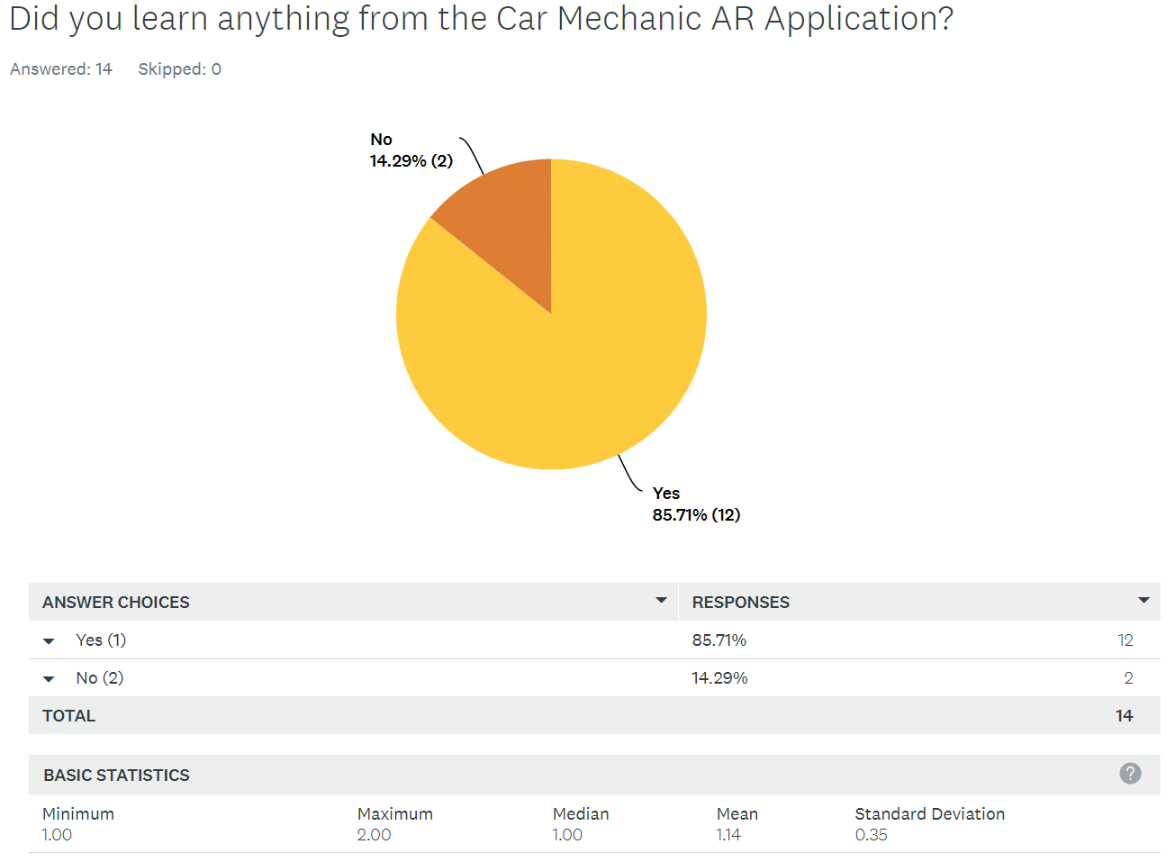

In figure 3.4 It shows that about 85.71% of students learned from using the *Car Mechanic AR Application* but 14.29% didn’t feel like that learned anything from the application. As you can see that most of the students gained knowledge from the AR experience which is a good thing because they could use this knowledge and apply it to their coursework. Also, since one of the goals of this project was to help students to learn about car components and how to fix common problems that can occur, it certainly proves that the application was successful.

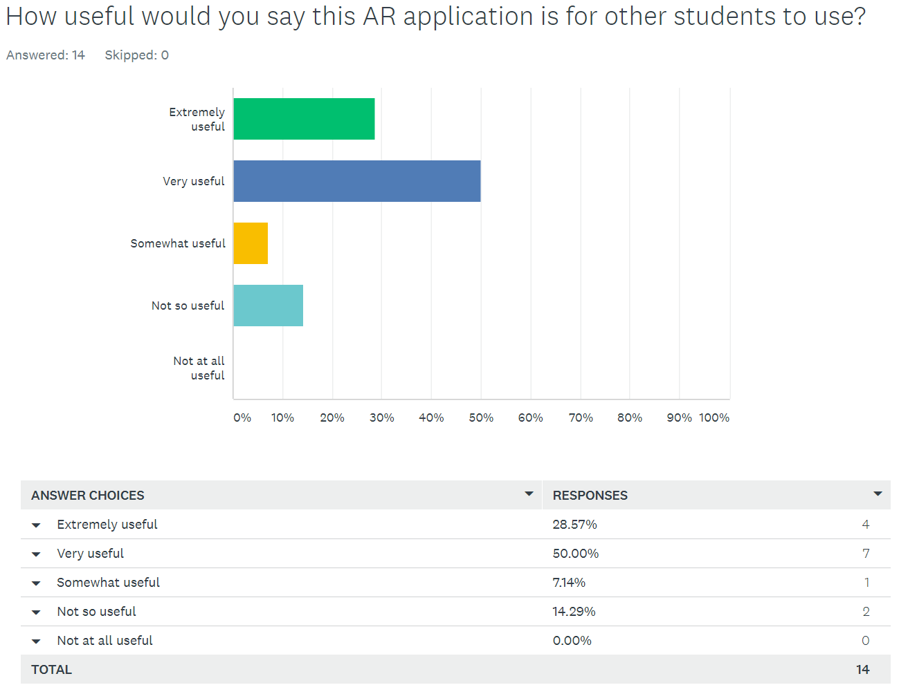

In figure 3.5 it shows that 28.7% of students felt that the application was extremely useful and 50% of the students felt that the application was very useful. But around 7.14% of students felt that the application was somewhat useful and 14.29% of students felt that the application was not so useful for other students to use. These results show that the majority of the students did find the application useful. Only one student didn’t think that the application would be useful for other students to use.

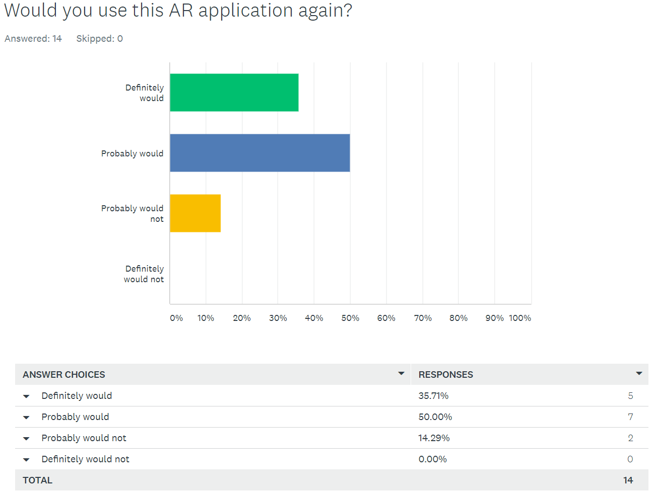

In figure 3.6 it shows that about 35.71% of students would definitely use the *Car Mechanic AR Application* again and 50% of students would probably use this AR application again. But around 14.29% of students may not use this AR application again. The results show that most of the students are likely to use the application in the future which means that the students enjoyed their experience. But for students to keep using this application, there would need to be some developments such as adding new features so that the users can experiment with application more.

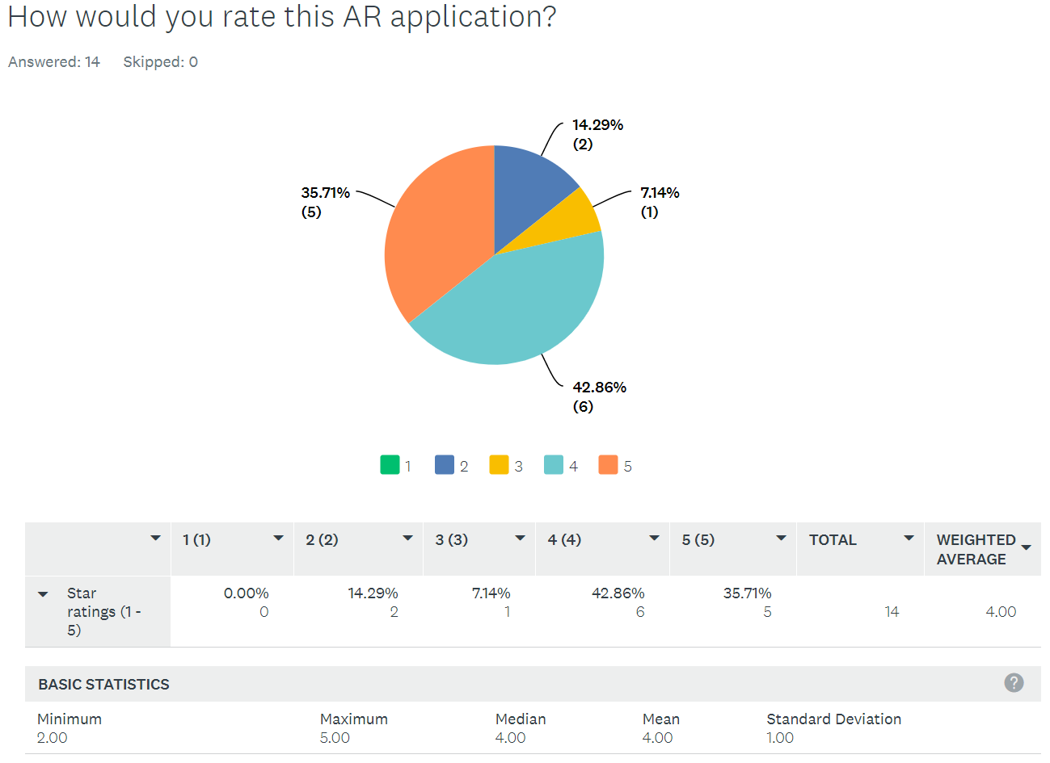

In figure 3.7 it shows the star ratings each student gave for the *Car Mechanic AR Application.* As you can see that about 35.71% of students gave 5-star ratings for the application, 42.86% of students gave the application 4-star ratings, 7.14% of students gave the application 3-star ratings and 14.29% of the students rated the application 2 stars. The average star rating calculated for the *Car Mechanic AR Application* is 4 stars out of a possible 5 which is a high enough score to say that the AR application was effectively designed and implemented well.

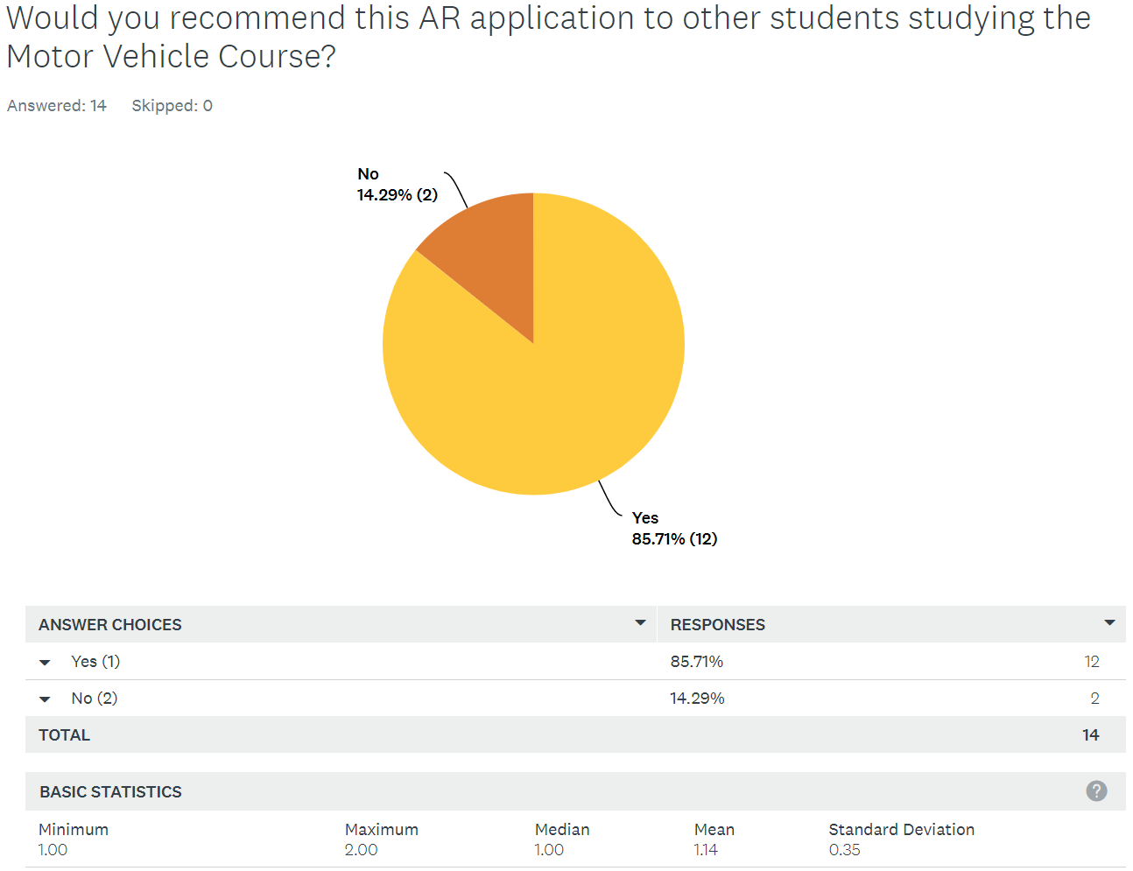

In figure 3.8 it shows that about 85.71% of students would recommend this AR application to other students studying the Motor Vehicle Course whereas 14.29% of students would not recommend it. It’s fair to say that most students recommended the application and therefore it shows that they enjoyed their AR experience. Since most students recommended this application for other students it could potentially be used as a revision tool to help the students revise for their online assessments.

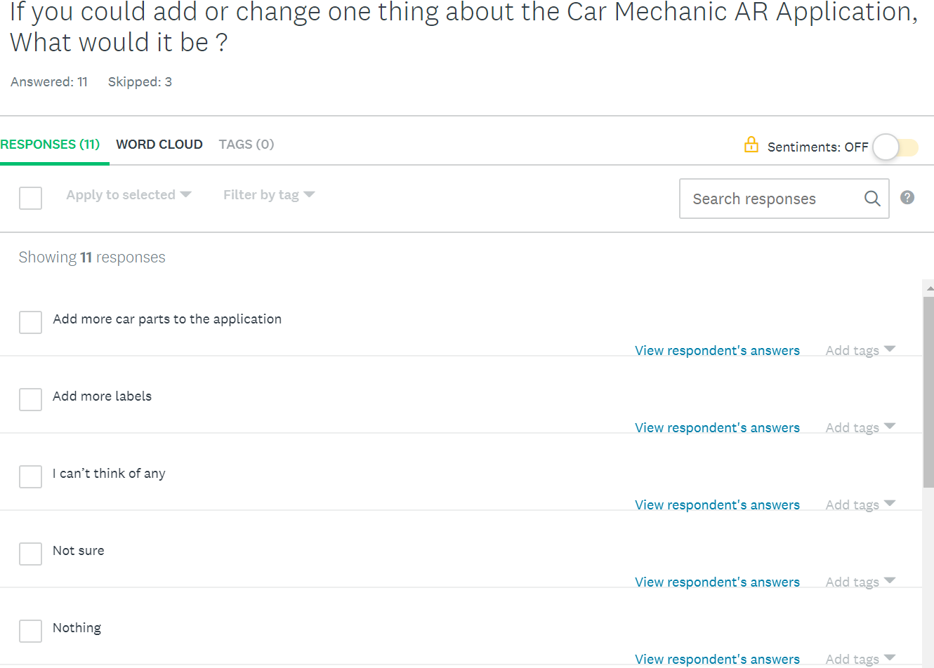

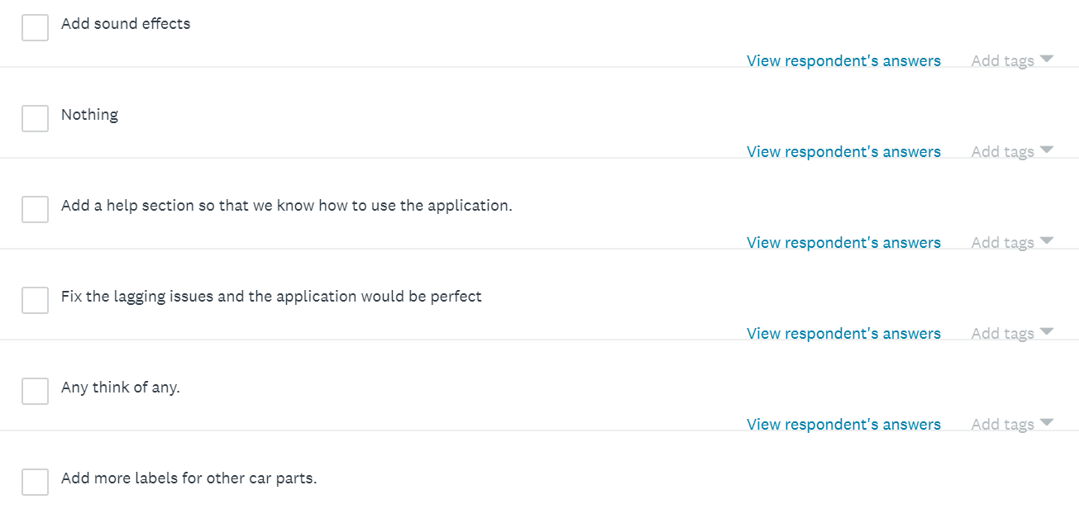

In figure 3.9 it shows the last question for the survey. This question involves the students to give their opinion or ideas of anything they think they could add or change about the *Car Mechanic AR Application.* There were 11 students that filled in this question and a majority of them gave some helpful ideas which can be used in future developments. But the main request from the students was to add more labels to the application which can be achieved in future development.

**6 Conclusion**

This section focuses on the *Car Mechanic AR Application’s* successes, failures, and future developments.

**6.1 Application Successes**

In conclusion, the *Car Mechanic AR Application* was a success as it did meet the requirements set in the project’s specification. Most users that tested the application really enjoyed the AR experience and learned a lot about the different car components and how to fix common problems that can occur. From the black box testing, it shows that every requirement passed the test which is why the user testing was a success. The user testing showed that most of the students felt that they learned from the information that’s was displayed on the labels which is very much what the project aim was all about. The users were able to detect different car components and view the information from different angles. But based on how the *Car Mechanic AR Application* is looking right now, it’s evident that there is further development required for the *Car Mechanic AR Application* to become a success and compete with other AR applications on the market on the market.

**6.2 Application Failures**

There were only a few failures that occurred in the *Car Mechanic AR Application.* For instance, as mentioned in the user testing section, there was a student that experienced some lag within the applications labels. This doesn’t normally occur, and it certainly didn’t occur when the Black box texting was performed. But it is possible that the *Car Mechanic AR Application* experience lag but for two main reasons. The first one is that there might be a network error which is stopping the *Car Mechanic AR Application* running all the features that it has. The second reason is that the device's processor might’ve been overheating due to performing multiple tasks at once which in result it will drop the frames per second in the application so that it can continue to cope with multitasking. If this is the case then the only way to fix this is to close all the unnecessary applications that are being run in the background and then re-open the *Car Mechanic AR Application.* If this doesn’t fix the lag issues, then the user may have to use a device that has a more powerful processor.

**6.3 Future Developments**

There are various ways where the *Car Mechanic AR Application* could improve and become a more advanced AR application. Below are some examples of ideas that should be taken into consideration if the application was to be developed further in the future.

**6.3.1 Quiz**

When the users have identified each car component and have read the information from the overhead labels, it would be good if they could attempt to complete a quiz to test their knowledge. This would be a great feature as the users will be able to put what they’ve learned to the test. There could be a scoring system which stores the user's results in each time they attempt the quiz.

**6.3.2 Login**

*Car Mechanic AR Application* would’ve benefited if it had a login page for many reasons. The first one is that only users that have registered for an account will be able to use the features within the *Car Mechanic AR Application.* This way no one that is unauthorized will be able to access the application. Another reason for implementing a login section is that users will have access to information about their progress. For example, when the user has been experimenting reading the *Car Mechanic AR Application’s* overhead labels they can attempt to complete a short quiz and they’ll receive a mark based on how well they do. This mark will be stored in their account so that they can track their progress.

**6.3.3 Responsive Overhead labels**

Although the overhead labels provide all the information need to explain what each car component does and how to fix common problems that can occur, there are other ways in which the labels could’ve been implemented to provide more enjoyable AR experience for the users. For example, the *Car Mechanic AR Application* could’ve displayed just the name of the car component and if the user wanted to know more information about it, all they have to do is tap on the label. The overhead label would enlarge and will display more information about the car component. This feature would require human interaction which is what the *Car Mechanic AR Application* should ideally have in order to make the users experience unforgettable.

**Bibliography**

Macwan, U. (2017, April 24). *Mobile Technology, Its Importance, Present And Future Trends*. Retrieved from https://www.finextra.com/blogposting/14000/mobile-technology-its-importance-present-and-future-trends

Admin. (2018, October 04). *What is Augmented Reality (AR)? Ultimate Guide to Augmented Reality (AR) Technology*. Retrieved from https://www.realitytechnologies.com/augmented-reality/

Works, H. A. (2015, February 04). ‎*How a Car Works.* Retrieved from: https://itunes.apple.com/app/how-a-car-works/id961583774

Golson, J.G. (2016, January 05). *Hyundai's augmented reality app helps idiot-proof car maintenance.* Retrieved from: https://www.theverge.com/2016/1/5/10712686/hyundai-augmented-reality-owners-manual-video-ar-ces-2016

Prabhu, S. (2017, December 18). *Types of Augmented Reality (for Me and my Business).* Retrieved from http://www.arreverie.com/blogs/types-of-augmented-reality/

Davis, J. (2017, August 22). *Marker and Markerless Augmented Reality.* Retrieved from https://www.trekk.com/insights/marker-and-markerless-augmented-reality

Team, T. (2019, January 29). *What is Augmented Reality (AR) and How does it work.* Retrieved from https://thinkmobiles.com/blog/what-is-augmented-reality/

Agarwal, P. (2019, January 05). *AUGMENTED REALITY: EXPLORED.* Retrieved from https://medium.com/acmvit/augmented-reality-explored-fc811b5eb770

Singh, H. (2018, February 23). *What is Augmented Reality? – Types of AR and Future of Augmented Reality.* Retrieved from https://dev.to/theninehertz/what-is-augmented-reality--types-of-ar-and-future-of-augmented-reality--1en0

Levski, Y. (2018, March 05). *5 Examples of Amazing Augmented Reality Car Repair Apps - AppReal-VR.* Retrieved from https://appreal-vr.com/blog/augmented-reality-car-repair/

I-Mechanic, the AR App that turns yourself into a Mechanic. (n.d.). Retrieved from http://www.armedia.it/i-mechanic

Pichikala, K. (2009, September 03). Retrieved from https://www.youtube.com/watch?v=Y5ywMb6SeGc

Inglobe. (2013, May 23). Retrieved from https://www.youtube.com/watch?time_continue=189&v=EUmNbNa3RYY

Fitzsimmons, M. (2018, June 04). *What is ARKit 2? Here's what you need to know about Apple's latest AR update.* Retrieved from https://www.techradar.com/uk/news/what-is-arkit-2-heres-what-you-need-to-know-about-apples-latest-ar-update

Axon, S. (2018, June 16). *How ARKit 2 works, and why Apple is so focused on AR.* Retrieved from https://arstechnica.com/gadgets/2018/06/arkit-2-why-apple-keeps-pushing-ar-and-how-it-works-in-ios-12/

Simone, S. D. (2018, June 05). *ARKit 2 Introduces Shared Experiences.* Retrieved from https://www.infoq.com/news/2018/06/arkit-2-ios12-shared-experiences

What is "usdz" and how it will change retail business. (2019, February 13). Retrieved from https://codeit.us/the-usdz-file/

Davies, C. (2018, June 06). *Here's how Apple is making AR objects far more believable.* Retrieved from https://www.slashgear.com/apple-arkit-2-ios-12-environment-texture-reflections-06533104/

The Good and the Bad of Swift Programming Language. (n.d.). Retrieved from https://www.altexsoft.com/blog/engineering/the-good-and-the-bad-of-swift-programming-language

Dotterweich, A. (2018, October 26). What is Black Box Testing? Retrieved from https://www.rainforestqa.com/blog/2018-10-26-what-is-black-box-testing/

Some Code taken from:

Advent, B. (2018, June 14). Brianadvent/3DObjectScanningAndDetection. Retrieved from https://github.com/brianadvent/3DObjectScanningAndDetection

**Appendix A**

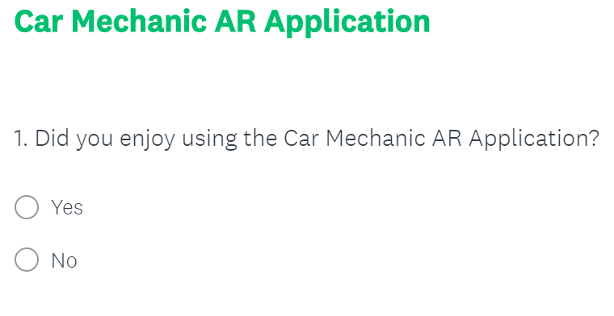

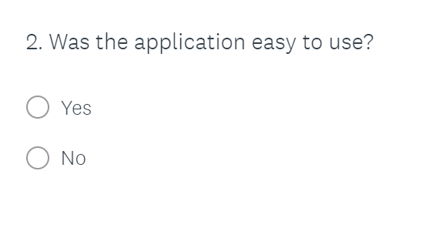

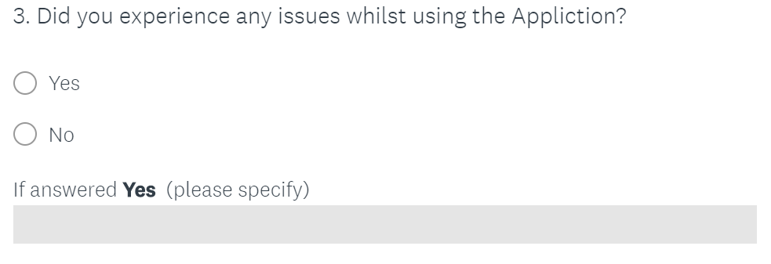

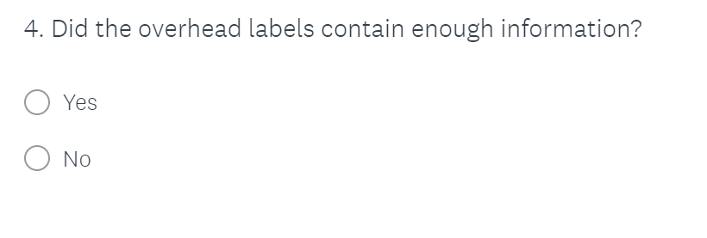

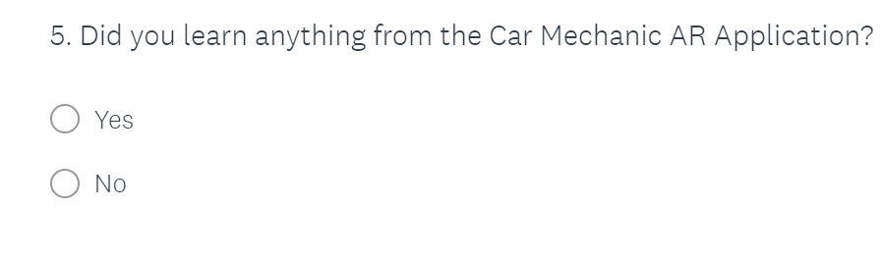

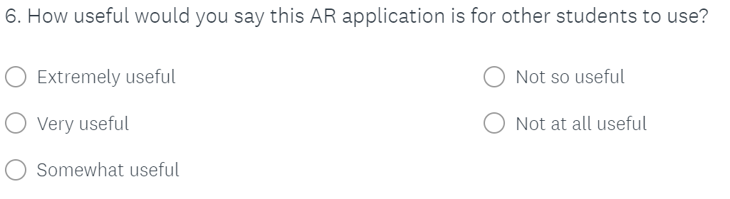

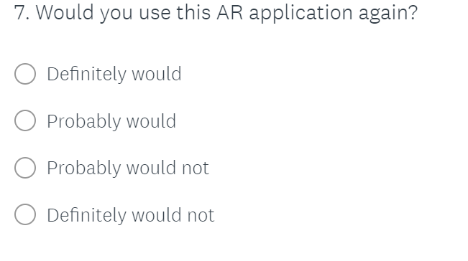



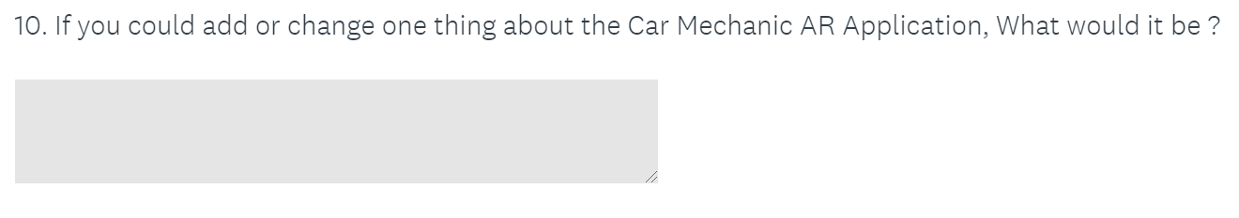

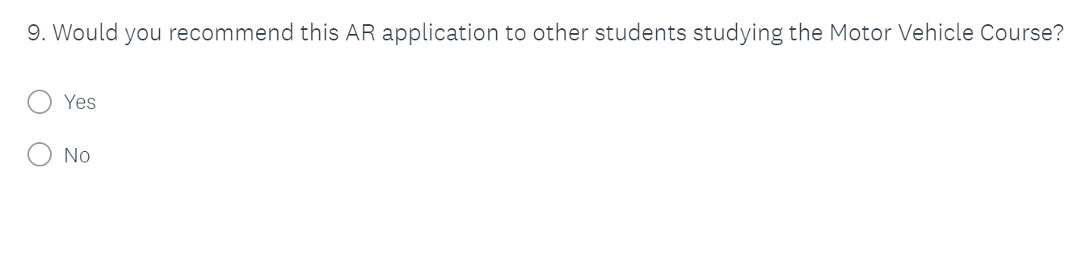

**Appendix B**



**Engine coolant Label**

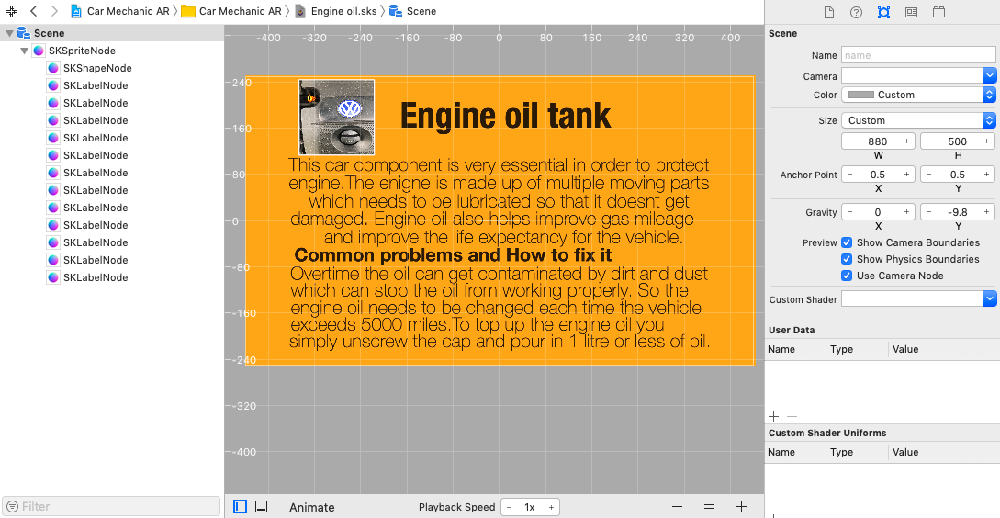

**Engine Oil Tank Label**

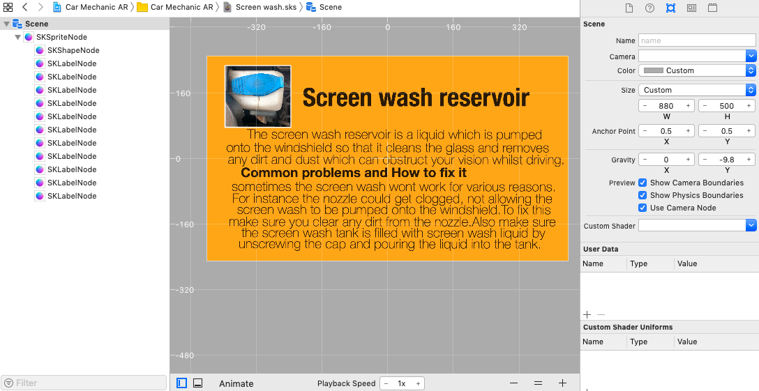

**Screen Wash Reservoir Label**

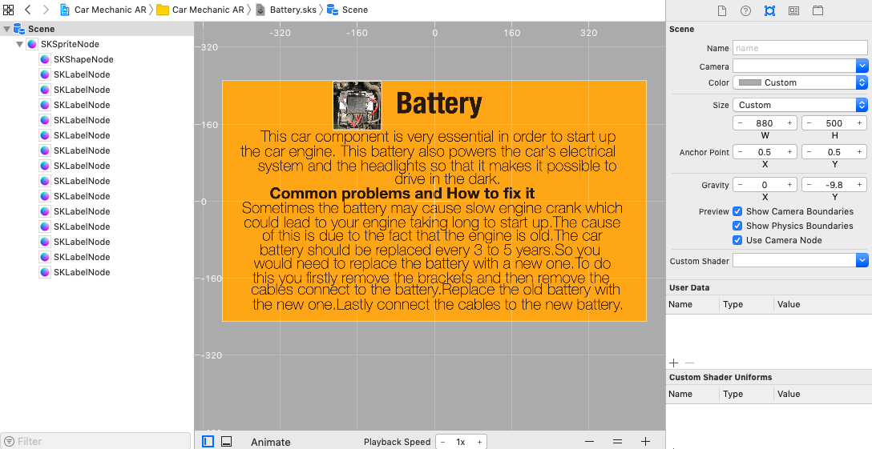

**Battery Label**

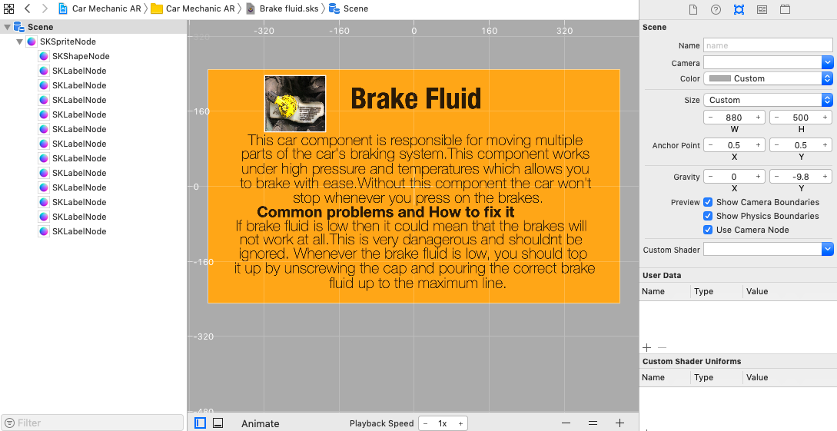

**Brake Fluid Label**

**Appendix C**

Screenshots

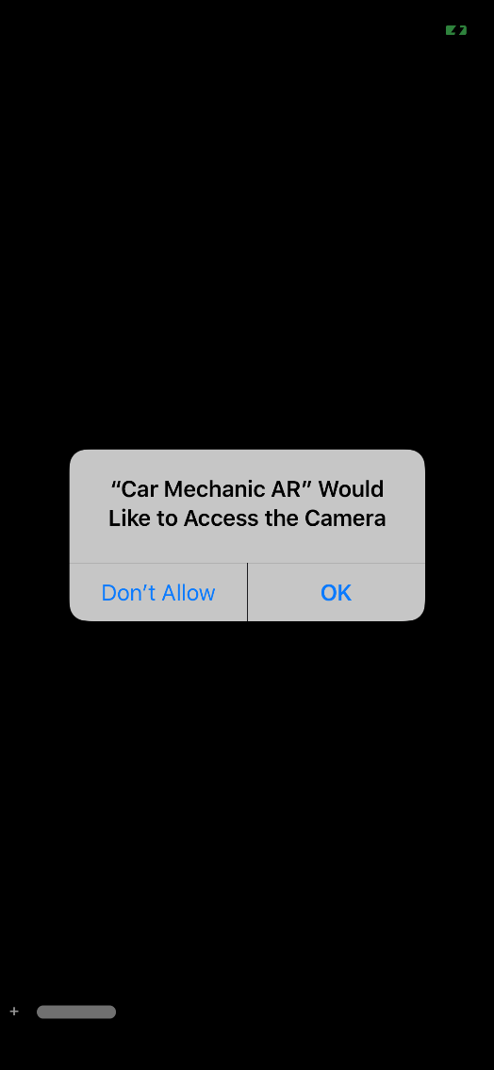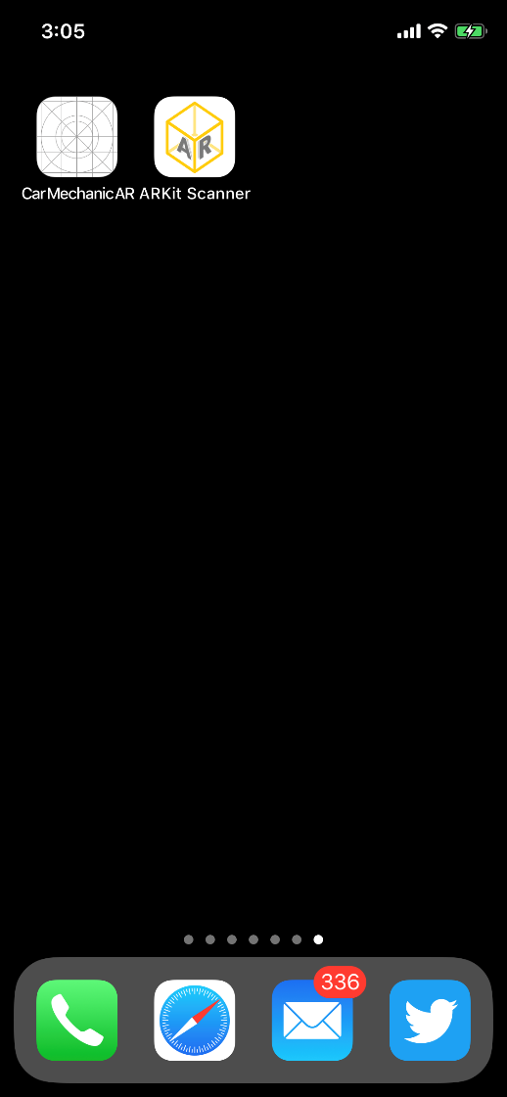

*Car Mechanic AR Application Icon* Access to the camera

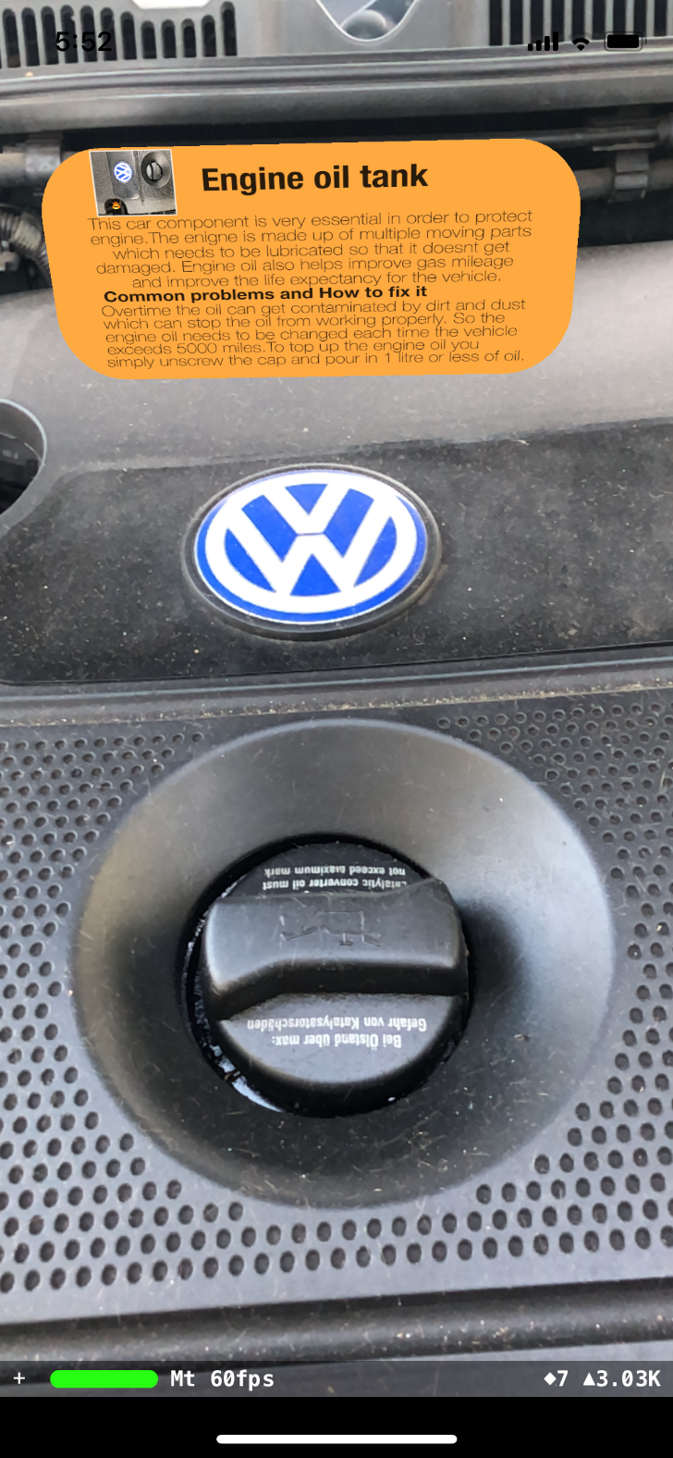

Engine Oil Tank component successfully detected, and the correct label is displayed above it.

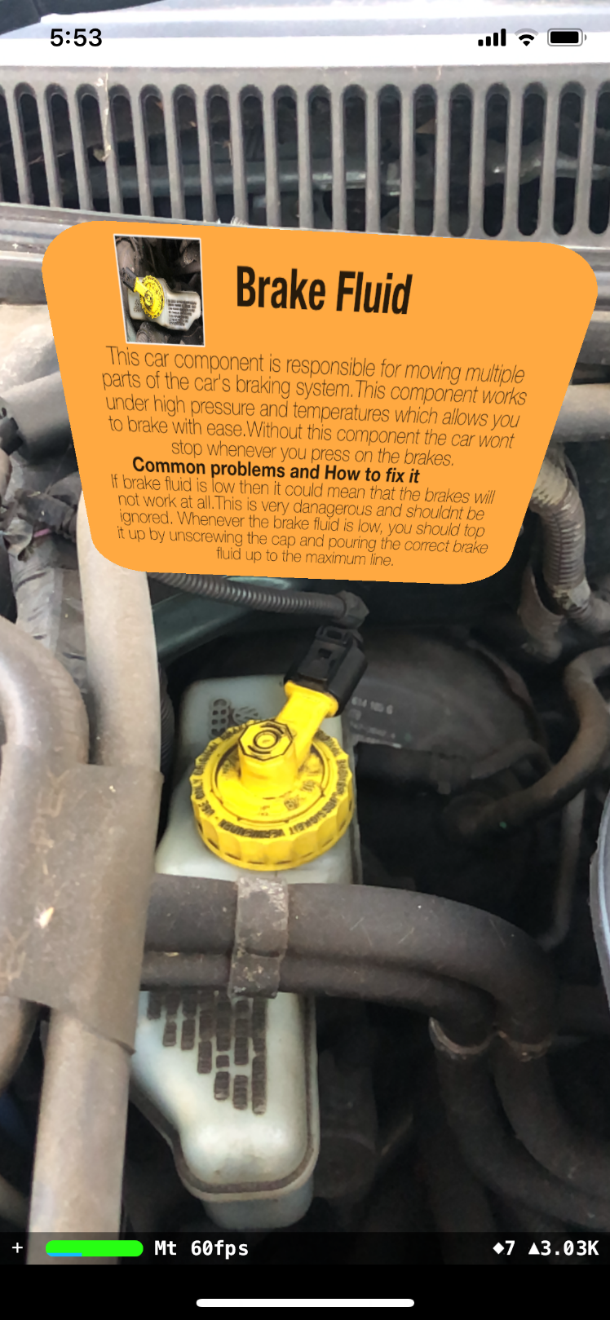

Brake fluid component successfully detected, and the correct label is displayed above it.

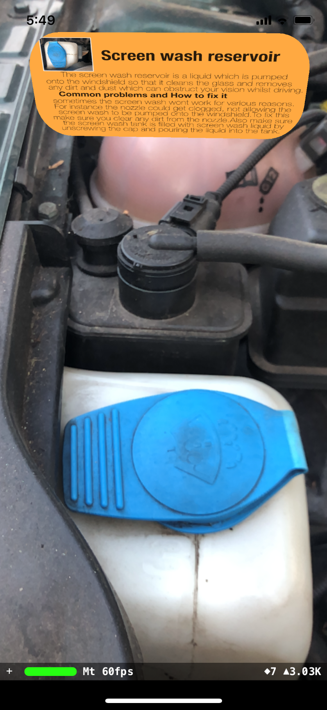

Screen Wash component successfully detected, and the correct label is displayed above it.

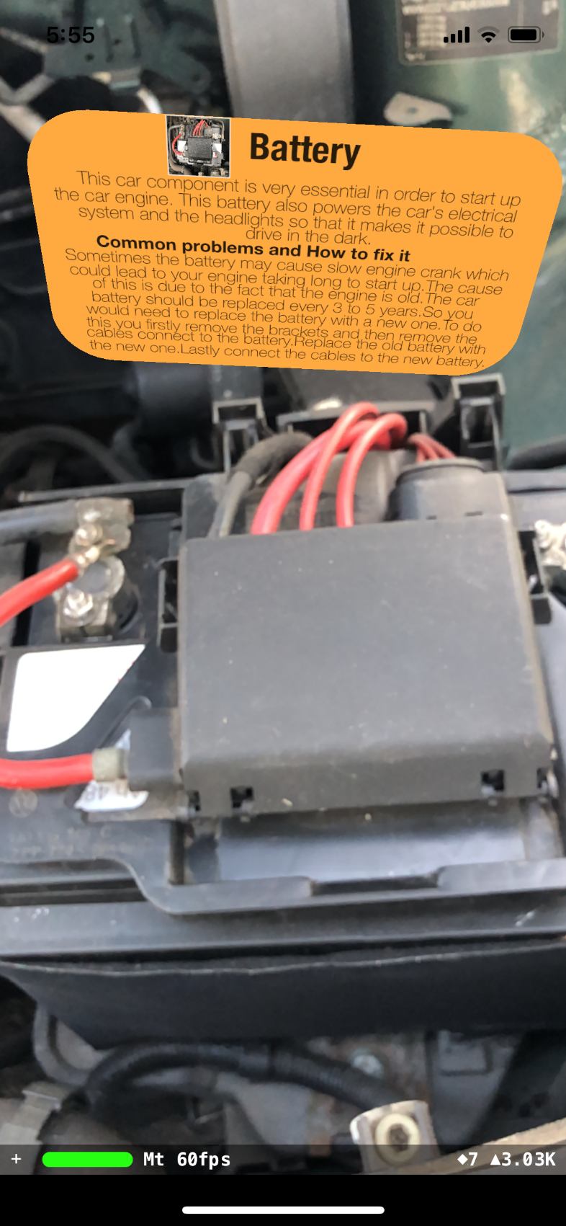

Battery component successfully detected, and the correct label is displayed above it.

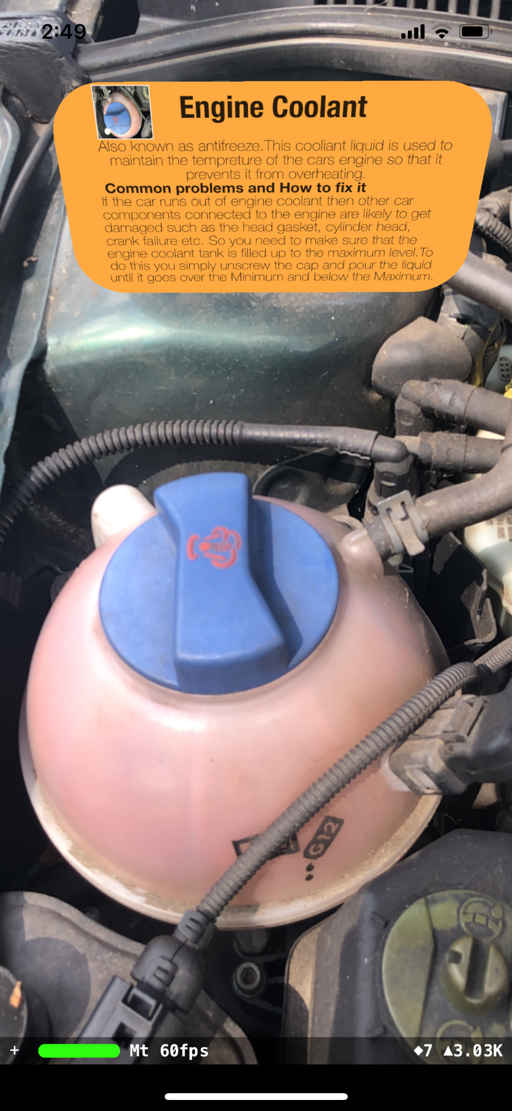

Engine Coolant component successfully detected, and the correct label is displayed above it.

**Appendix D**

//

// ViewController.swift

// Car Mechanic AR Application

//

// Created by Argjend Statovci

// Copyright © 2019 Argjendproject. All rights reserved.

//

**import** UIKit

**import** SceneKit

**import** ARKit

**class** **ViewController**: **UIViewController**, **ARSCNViewDelegate** {

@IBOutlet **var** sceneView: ARSCNView!

**override** **func** **viewDidLoad**() {

**super**.viewDidLoad()

// Set the view's delegate

sceneView.delegate = **self**

// Show statistics such as fps and timing information

sceneView.showsStatistics = true

// Create a new scene

**let** scene = SCNScene(named: "art.scnassets/scene.scn")!

// Set the scene to the view

sceneView.scene = scene

}

**override** **func** **viewWillAppear**(_ animated: Bool) {

**super**.viewWillAppear(animated)

// Create a session configuration for the scanned components

**let** configuration = ARWorldTrackingConfiguration()

//configuration.detectionObjects = ARReferenceObject.referenceObjects(inGroupNamed: "ARSCAN",

// bundle: Bundle.main)!

//configuring the scanned components so that they can be detected

configuration.detectionObjects = ARReferenceObject.referenceObjects(inGroupNamed: "AR Resources",//

bundle: Bundle.main)!

// begin the view's session

sceneView.session.run(configuration)

}

**override** **func** **viewWillDisappear**(_ animated: Bool) {

**super**.viewWillDisappear(animated)

// Pause the view's session

sceneView.session.pause()

}

// MARK: - ARSCNViewDelegate

/*

// Override to create and configure nodes for anchors added to the view's session.

func renderer(_ renderer: SCNSceneRenderer, nodeFor anchor: ARAnchor) -> SCNNode? {

let node = SCNNode()

return node

}

*/

**func** **renderer**(_ renderer: SCNSceneRenderer, nodeFor anchor: ARAnchor) -> SCNNode? {

**let** node = SCNNode()

**if** **let** objectAnchor = anchor **as**? ARObjectAnchor {

//defining a plane and setting the height and width

**let** plane = SCNPlane(width: CGFloat(objectAnchor.referenceObject.extent.x * 0.9),

height:CGFloat(objectAnchor.referenceObject.extent.y * 0.6))

//creating a corner radious for the labels

plane.cornerRadius = plane.width * 0.235

//display the spritekit scene

**let** displayScene = SKScene(fileNamed: "Engine coolant")

plane.firstMaterial?.diffuse.contents = displayScene

//make the labels doublesided

plane.firstMaterial?.isDoubleSided = true

plane.firstMaterial?.diffuse.contentsTransform = SCNMatrix4Translate(SCNMatrix4MakeScale(1, -1, 1), 0, 1, 0)

//creating a plane node

**let** planeNode = SCNNode(geometry: plane)

//positioning the planeNode so that label appear over the detected car component

planeNode.position = SCNVector3Make(objectAnchor.referenceObject.center.x,

objectAnchor.referenceObject.center.y + 0.20, objectAnchor.referenceObject.center.z)

node.addChildNode(planeNode)

}

**return** node

}

**func** **renderer2**(_ renderer2: SCNSceneRenderer, nodeFor anchor_two: ARAnchor) -> SCNNode? {

**let** node = SCNNode()

**if** **let** objectAnchor_two = anchor_two **as**? ARObjectAnchor {

//defining a plane and setting the height and width

**let** plane = SCNPlane(width: CGFloat(objectAnchor_two.referenceObject.extent.x * 0.9),

height:CGFloat(objectAnchor_two.referenceObject.extent.y * 0.6))

//creating a corner radious for the labels

plane.cornerRadius = plane.width * 0.235

//display the spritekit scene

**let** displayScene = SKScene(fileNamed: "Brake fluid")

plane.firstMaterial?.diffuse.contents = displayScene

//make the labels doublesided

plane.firstMaterial?.isDoubleSided = true

plane.firstMaterial?.diffuse.contentsTransform = SCNMatrix4Translate(SCNMatrix4MakeScale(1, -1, 1), 0, 1, 0)

//creating a plane node

**let** planeNode = SCNNode(geometry: plane)

//positioning the planeNode so that label appear over the detected car component

planeNode.position = SCNVector3Make(objectAnchor_two.referenceObject.center.x,

objectAnchor_two.referenceObject.center.y + 0.20, objectAnchor_two.referenceObject.center.z)

node.addChildNode(planeNode)

}

**return** node

}

**func** **renderer_three**(_ renderer_three: SCNSceneRenderer, nodeFor anchor_three: ARAnchor) -> SCNNode? {

**let** node = SCNNode()

**if** **let** objectAnchor_three = anchor_three **as**? ARObjectAnchor {

//defining a plane and setting the height and width

**let** plane = SCNPlane(width: CGFloat(objectAnchor_three.referenceObject.extent.x * 0.9),

height:CGFloat(objectAnchor_three.referenceObject.extent.y * 0.6))

//creating a corner radious for the labels

plane.cornerRadius = plane.width * 0.235

//display the spritekit scene

**let** displayScene = SKScene(fileNamed: "Engine oil")

plane.firstMaterial?.diffuse.contents = displayScene

//make the labels doublesided

plane.firstMaterial?.isDoubleSided = true

plane.firstMaterial?.diffuse.contentsTransform = SCNMatrix4Translate(SCNMatrix4MakeScale(1, -1, 1), 0, 1, 0)

//creating a plane node

**let** planeNode = SCNNode(geometry: plane)

//positioning the planeNode so that label appear over the detected car component

planeNode.position = SCNVector3Make(objectAnchor_three.referenceObject.center.x,

objectAnchor_three.referenceObject.center.y + 0.20, objectAnchor_three.referenceObject.center.z)

node.addChildNode(planeNode)

}

**return** node

}

**func** **renderer_four**(_ renderer_four: SCNSceneRenderer, nodeFor anchor_four: ARAnchor) -> SCNNode? {

**let** node = SCNNode()

**if** **let** objectAnchor_four = anchor_four **as**? ARObjectAnchor {

//defining a plane and setting the height and width

**let** plane = SCNPlane(width: CGFloat(objectAnchor_four.referenceObject.extent.x * 0.9),

height:CGFloat(objectAnchor_four.referenceObject.extent.y * 0.6))

//creating a corner radious for the labels

plane.cornerRadius = plane.width * 0.235

//display the spritekit scene

**let** displayScene = SKScene(fileNamed: "Screen wash")

plane.firstMaterial?.diffuse.contents = displayScene

//make the labels doublesided

plane.firstMaterial?.isDoubleSided = true

plane.firstMaterial?.diffuse.contentsTransform = SCNMatrix4Translate(SCNMatrix4MakeScale(1, -1, 1), 0, 1, 0)

//creating a plane node

**let** planeNode = SCNNode(geometry: plane)

//positioning the planeNode so that label appear over the detected car component

planeNode.position = SCNVector3Make(objectAnchor_four.referenceObject.center.x,

objectAnchor_four.referenceObject.center.y + 0.20, objectAnchor_four.referenceObject.center.z)

node.addChildNode(planeNode)

}

**return** node

}

**func** **renderer_five**(_ renderer_five: SCNSceneRenderer, nodeFor anchor_five: ARAnchor) -> SCNNode? {

**let** node = SCNNode()

**if** **let** objectAnchor_five = anchor_five **as**? ARObjectAnchor {

//defining a plane and setting the height and width

**let** plane = SCNPlane(width: CGFloat(objectAnchor_five.referenceObject.extent.x * 0.9),

height:CGFloat(objectAnchor_five.referenceObject.extent.y * 0.6))

//creating a corner radious for the labels

plane.cornerRadius = plane.width * 0.235

//display the spritekit scene

**let** displayScene = SKScene(fileNamed: "Battery")

plane.firstMaterial?.diffuse.contents = displayScene

//make the labels doublesided

plane.firstMaterial?.isDoubleSided = true

plane.firstMaterial?.diffuse.contentsTransform = SCNMatrix4Translate(SCNMatrix4MakeScale(1, -1, 1), 0, 1, 0)

//creating a plane node

**let** planeNode = SCNNode(geometry: plane)

//positioning the planeNode so that label appear over the detected car component

planeNode.position = SCNVector3Make(objectAnchor_five.referenceObject.center.x,

objectAnchor_five.referenceObject.center.y + 0.20, objectAnchor_five.referenceObject.center.z)

node.addChildNode(planeNode)

}

**return** node

}

**func** **session**(_ session: ARSession, didFailWithError error: Error) {

// Present an error message to the user

}

**func** **sessionWasInterrupted**(_ session: ARSession) {

// Inform the user that the session has been interrupted, for example, by presenting an overlay

}

**func** **sessionInterruptionEnded**(_ session: ARSession) {

// Reset tracking and/or remove existing anchors if consistent tracking is required

}

}

**Appendix E**

